In order to access the New MIS system, we recommend to use either Firefox or CHROME browser and compulsorily and exclusively the English Language Option, which is the official language of the Programme.

    - Applying for a new User Account
Access to the application is possible through the link https://logon.ops.gr/ops_sec/register/ once you enter, the following image will appear on your screen (Picture 1)
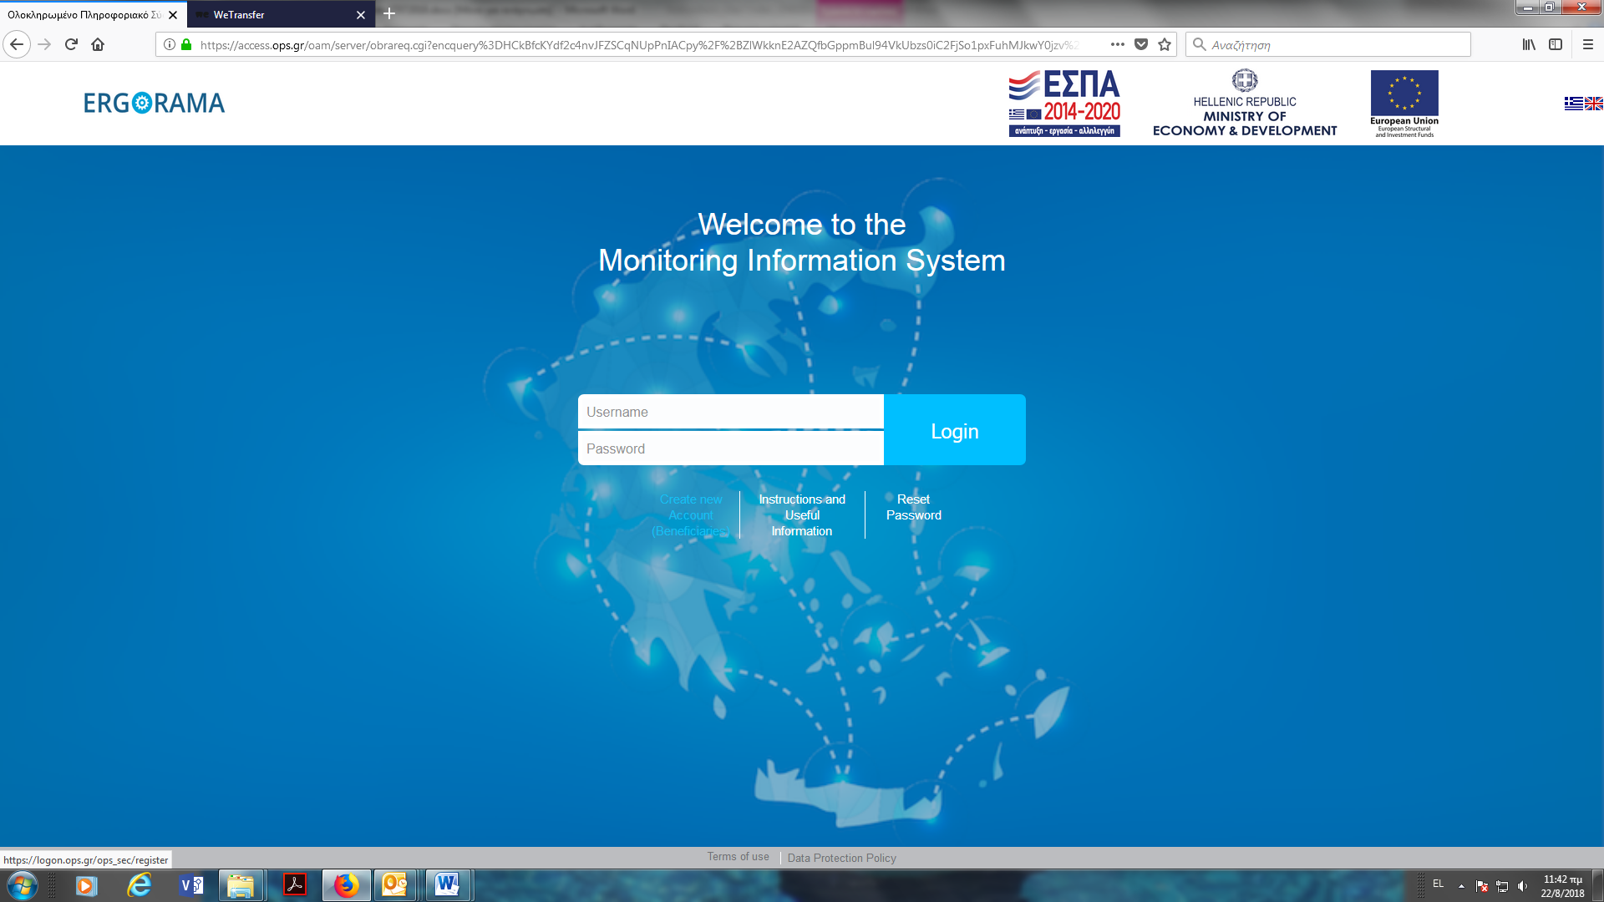
Picture 1

1.a Personal Data
In sections “Personal Data”, the user should fill in personal data only on compulsory fields (Fields with the red asterisk). CAPITAL letters are advised to be used in fields Surname, Name and Address.
Concerning Body code, if an already approved proposal is to be entered in the system, then the body code used in the proposals is to be filled in.
If the user is to enter a new proposal not approved and the body code is not found in the system, then the user should contact the JS on the program he / she is interested in applying for.
The body code is selected from the system or can be easily found on the attached list of bodies/beneficiaries. Although the filed body code is not noted with a red asterisk, it is absolutely required, in order for your application to be approved by the MA (Picture 2)
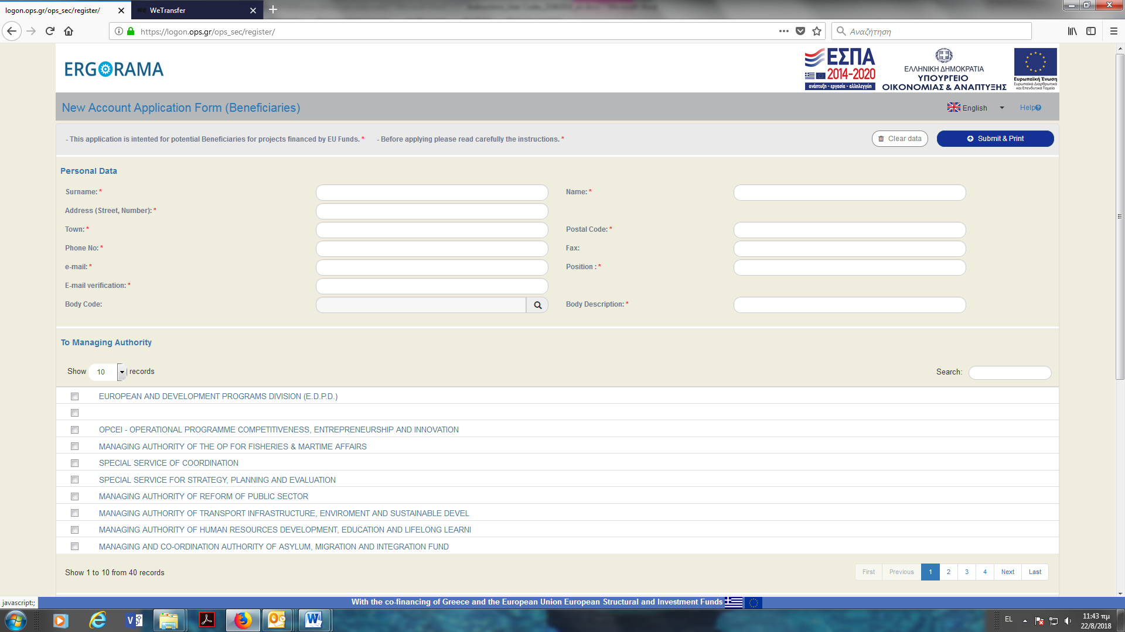
Picture 2

1.b To Managing Authority
On the file “To Managing Authority”, the user must select “MANAGING AUTHORITY OF EUROPEAN TERRITRIAL COOPERATION PROGRAMMES” (Picture 3)
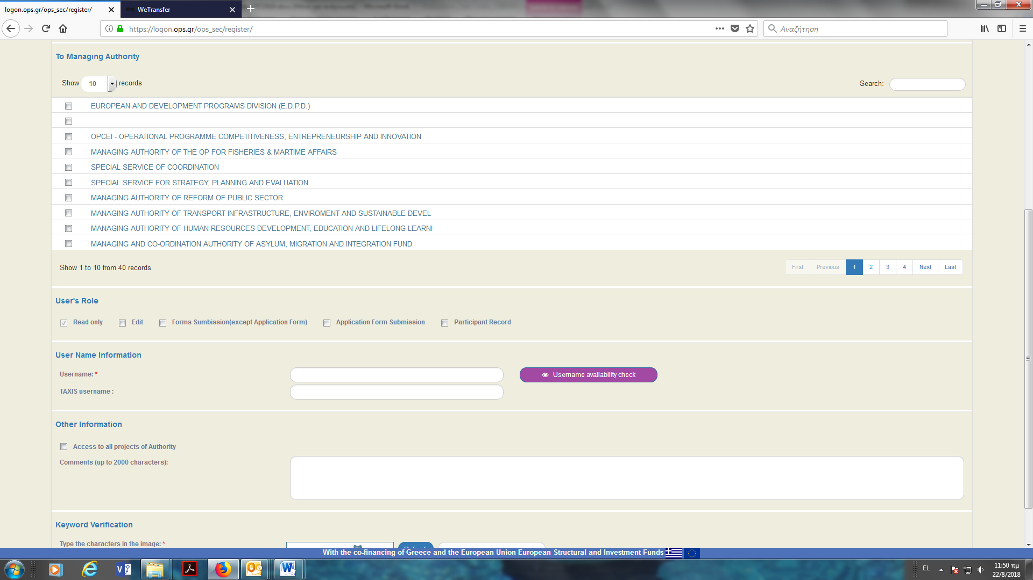
Picture 3

1.c User’s role
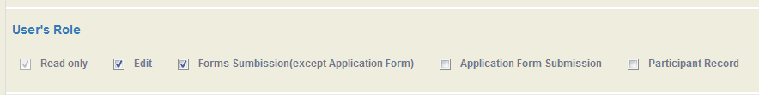
The access rights of the system are listed and explained below. (Picture 4)
Picture 4

- Read only (Read only Access to all screens)
- Edit (Edit Access to all screens)
- Forms Submission (except Application Form) (Insert data and Submission for Progress Reports, Table of expenditure, PDE Funding Request from Greek beneficiaries, Cost Verification Requests)
- Application Form Submission (Insert data and Submission of an Application form)
- Participant Record (THIS DOES NOT APPLY TO INTERREG PROGRAMMES, PLEASE DO NOT SELECT)
according to the needs of the body he / she belongs to.
We advise that in each body there will be at least two users.
Lead Beneficiary bodies must have at least one user with rights “Application Form Submission” and one with rights “Edit” and “Forms Submission (except Application Form)”.
Beneficiaries’ bodies must have at least one user with rights “Edit” and “Forms Submission (except Application Form)”.

1.d Credentials
Picture 5
By default, the system will propose your email as username. If the user wishes to select a different one, then the new one must be 5-8 digits alphanumeric. A check for the availability of the new password much be done (Picture 5).
If the proposed username is already taken, it may be partly modified. Your credentials will be sent automatically to the email account that the user has entered in its application in the section “Personal data”.
The user completes the remaining data.

1.e Submit and Print
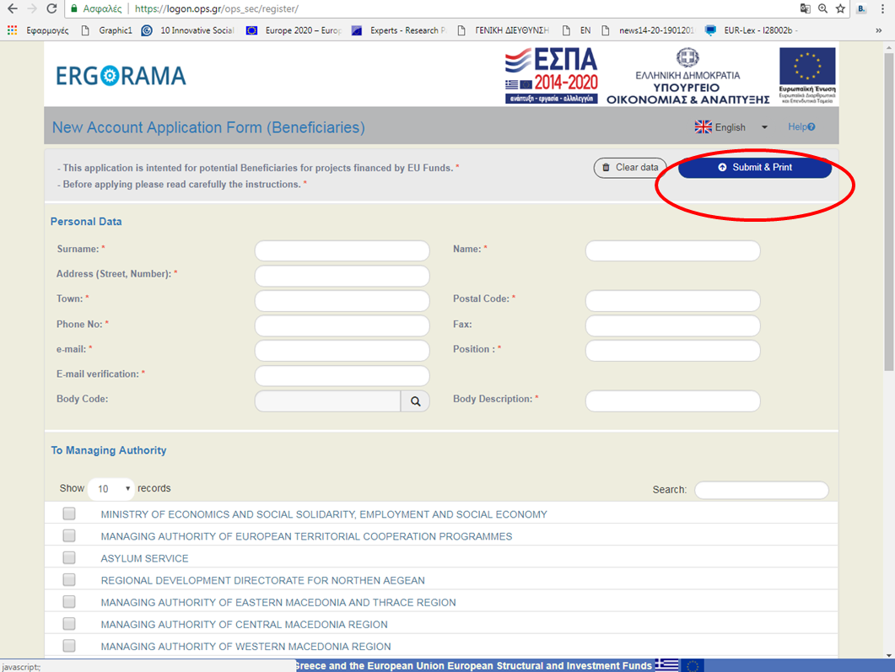
Picture 6
Once the button “Submit & Print” is clicked, a pdf archive of the user’s application will be generated. Be sure that your pop-up windows are enabled / allowed. If the pop-ups are blocked, the application form will not be generated. The system will send the archive also to the stated email address, if the applicant answers YES to the relevant question. (Picture 6)
The form produced must be printed, stamped and signed properly, both by the Legal Representative of the Body and the Applicant and sent scanned as a pdf file via e-mail (scanned in pdf format is required, photos will be not accepted) to jts_grbg@mou.gr. Once submitted, changes on the user account concerning the applicant’s rights and contact details can be done though a specific procedure (see section 2.b Managing User Account Rights).
Summarizing all of the above, for an application to be correct, the following must appear:
At the left hand side of the application
1. Date
2. Signature of the legal representative of your body
3. Name of the legal representative of your body
4. Official Stamp of your body

At the right hand side of the application:
1. Signature of the person requesting the username and password

- User Account Management
Please find below some important information regarding the user account for the MIS system, its management and the way of resolving problems that may occur:
2.a Acquiring Password
If a user has already requested and received a password during the MIS transition stage (before the 31/3/2018), he/ she should have received by now an email from the noreply@mnec.gr email account, which would have been confirming the use of the old username and password or would have sent new codes.
The email may have been moved to the spam folder or cut off from the email server. The user must consult the email administrator, to ensure that the email messages from the MIS Service are not cut off by your server. This is very important as, if the server cuts off all emails from the MIS system, the user will not be receiving important information regarding the project.
If the email has been received, then the user should:
- Try logging in to the system through the URL https://logon.ops.gr which is the address of the New MIS
- If logging in is successful, then this is the username and password of the user. The password is for personal use and should not be shared with other users. The password is advised to be changed the first time the user enters the system.
- If you did not succeed logging in and a system message “error” or "Authentication failed" is displayed, the user should reset the password through the option “Reset Password” in the initial screen(Picture 1)
If the email has not been the received, then the user should:
- Reset the password through the option “Reset Password” in the initial screen. A new password will be sent by the system within the next few minutes by the noreply@mnec.gr email account (Picture 7)

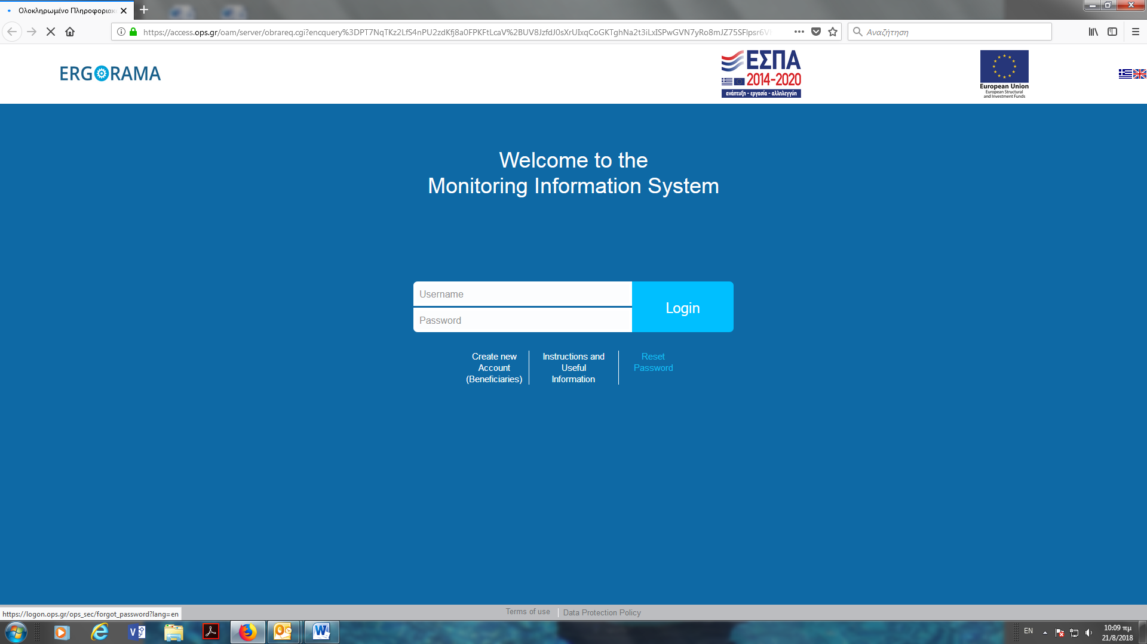
Picture 7
Even if the logging in is successfully, it is possible that the wrong screens are displayed. To check that the correct screens are displayed, one should see in the electronic submission of the Application Form the following:
A. Project Identification
B. Detailed Description
C. Partnership
D. Budget
E. Monitoring Indicators
F. Checklist for Submission
G. Attachments
H. History of Changes

If screens E1 and E2 are displayed, the user must contact Mrs. Brozou at abrozou@mou.gr stating the exact problem. The account will be fixed and the user will be informed as soon as possible.
If a user already has an account for ESPA projects, this account cannot be used for the INTERREG Programmes. The user should apply for a new account. If the user has already used the ESPA account for the INTERREG Programmes he/she must contact Mrs. Brozou at abrozou@mou.gr stating the exact problem.

2.b Managing User Account Rights
When all issues regarding the username and password are resolved, the user should check the rights he / she has received at his / her request.
As mentioned in section 1.c User’s role the access rights of the system are listed and explained below:
- Read only (Read only Access to all screens)
- Edit (Edit Access to all screens)
- Forms Submission (except Application Form) (Insert data and Submission for Progress Reports, Table of expenditure, PDE Funding Request from Greek beneficiaries from Greek beneficiaries, Cost Verification Requests)
- Application Form Submission (Insert data and Submission of an Application form)
- Participant Record (THIS DOES NOT APPLY TO INTERREG PROGRAMMES, PLEASE DO NOT SELECT)
The rights that have been requested and granted to the user can be seen after logging in the MIS platform, by selecting from the top right corner of the screen, below the username, the option "User Profile", as shown in the pictures below. (Picture 8 and 9)
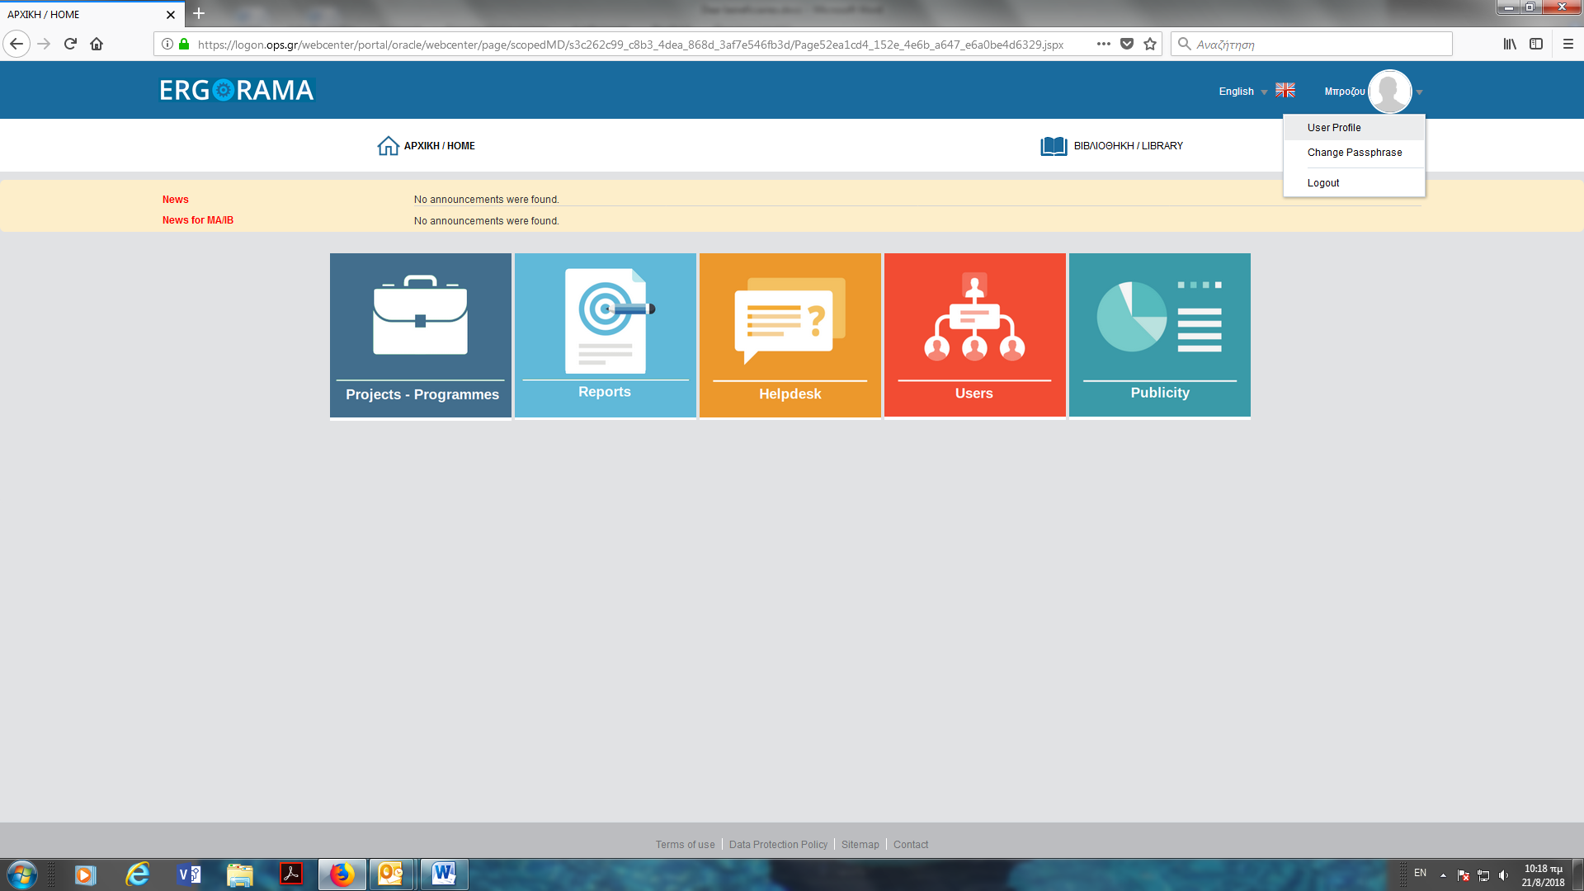
Picture 8

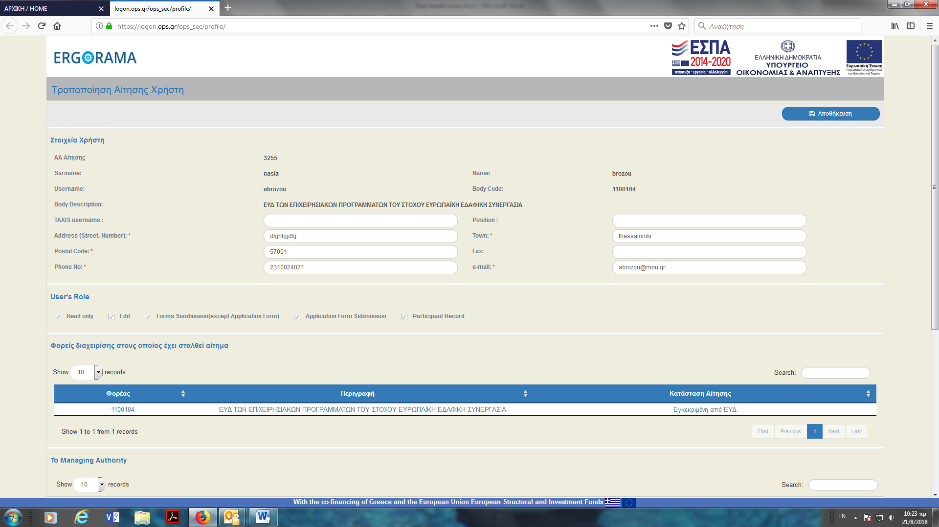
Picture 9
If a user wishes to change the user rights of its account, the legal representative of the user’s body needs to send to the Managing Authority an official letter stating the Application No, username and the rights that he wishes to give to the user.
The letter needs to have:
- Signature of the legal representative of the body
- Name of the legal representative of the body
- Official Stamp of the body

