MINISTRY OF ECONOMY AND DEVELOPMENT

GENERAL SECRETARIAT FOR PUBLIC INVESTMENTS & NSRF

NATIONAL COORDINATION UNIT
SPECIAL SERVICE FOR THE MONITORING INFORMATION SYSTEM

Implementation of the Monitoring Information System (MIS)
In compliance with the requirements of the Programming Period
2014 -2020

Electronic System for the monitoring of nsrf programmes and projects

User's Manual (Controller)
Project MONITORING TABLE OF EXPENDITURE
(European territorial cooperation PROGRAMMES)

Version: 01.00

TABLE OF CONTENTS
TABLE OF CONTENTS 3
1. ETC Table of Expenditure - Controller 4
1.1 Searching an ETC Table of Expenditures - Controller 4
1.2 Editing Table of Expenditures (ETC) Controller 5
1.2.1 A Table of Expenditure without discrepancies 5
1.2.2 Table of Expenditure with discrepancies 6
1.3 Return of the Table of Expenditure 11
1.4 Table of Expenditure Verification 12
1.5 Communication 13
1.6 ETC Table of Expenditure Actions 15

ETC Table of Expenditure - Controller

Searching an ETC Table of Expenditures - Controller
- The Controller receives an email informing him that the Beneficiary submitted the Table of Expenditure. The email also indicates the ID of the Table of Expenditure (ID 22337).
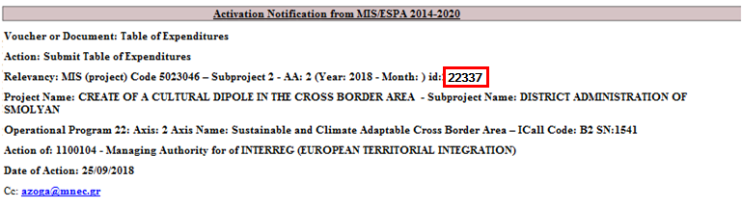
- Login into the Electronic System for the monitoring of NSRF programmes and projects (MIS) (see Section 2.1 of the User Application Manual).
- From the Main Menu of the MIS, the User selects the path: (1) ETC / ΕΕΣ → (2) Monitoring → (3) Table of Expenditures (ToE).
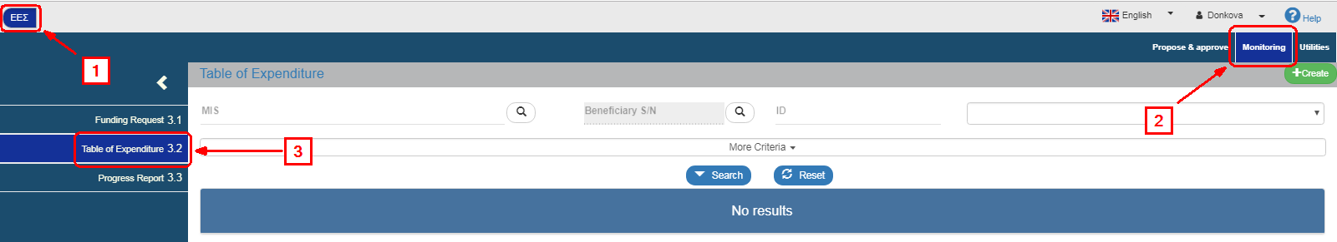
- Τhe ToE search screen pops-up on the interface with the "main" search criteria, as shown on the figure below. The Controller enters the ToE ID in the respective field (1) and makes the search (2).
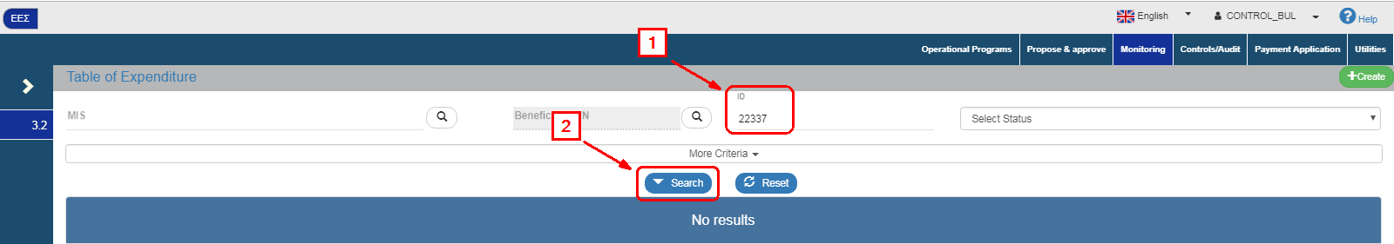
- After the search, the requested Table of Expenditure appears on the Table of Results.
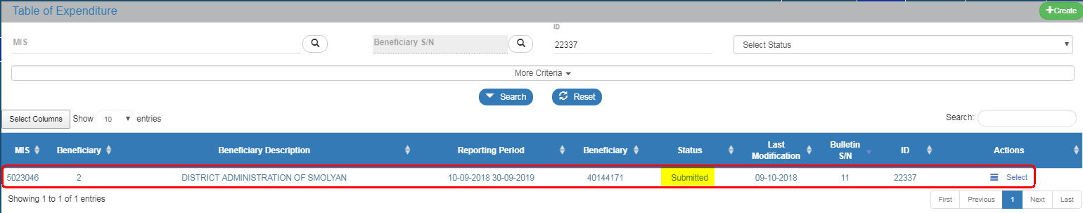

Editing Table of Expenditures (ETC) Controller
- The Controller selects “Edit” from the “Actions” column of the Table of Results.
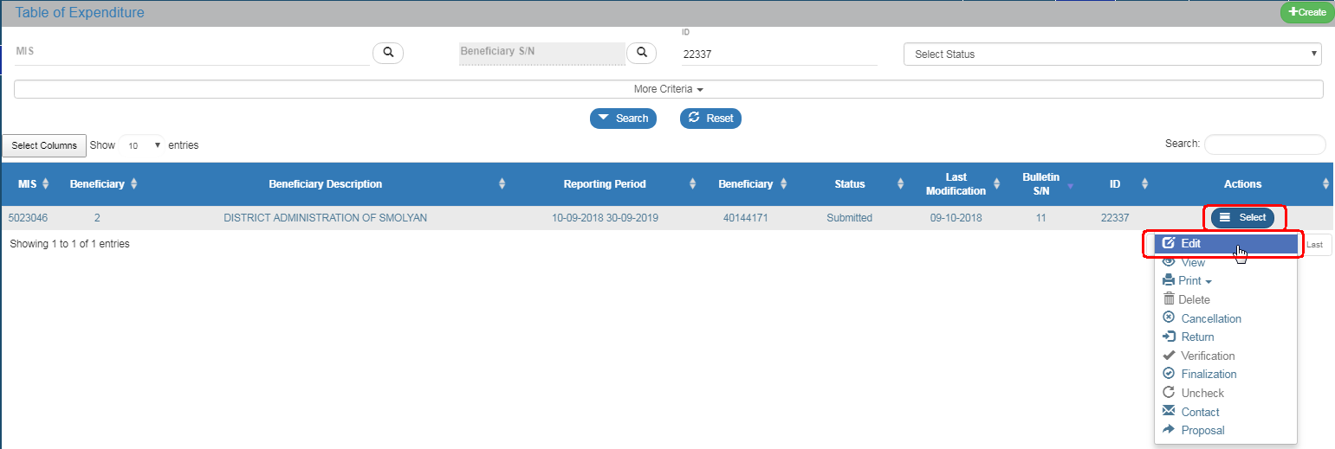
- The system displays the “Table of Expenditure - Edit“ screen and the Controller presses “Save” (1) on the tool bar (menu). On the warning message that appears (2), he selects “Yes” (3) and the status of the Table of Expenditure changes to “Being Processed” (4).
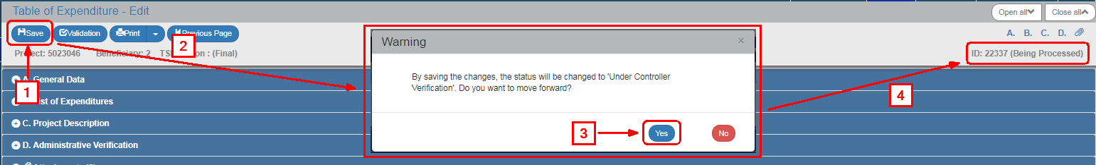

A Table of Expenditure without discrepancies
- The Controller examines the Table of Expenditure and, more specifically the correlations table under the “B. List of Expenditures” and does not find any non-eligible expenditure.
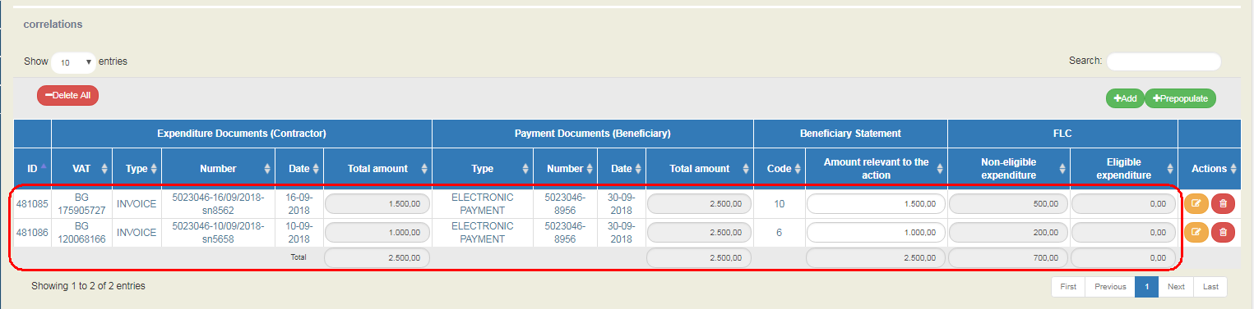
- He selects the “D. Administrative Verification” section and fills in the “Controller” field (1) and the Administrative Verification questions (2) with remarks, if any. Finally, he selects “Save” (3) on the tool bar (menu).
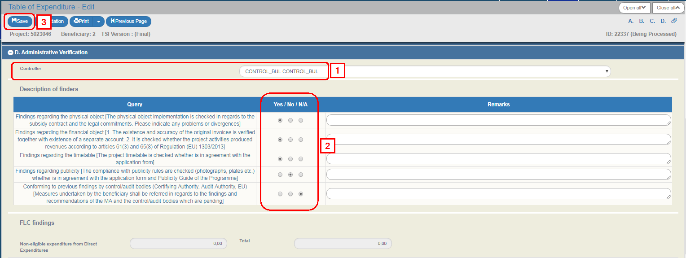
- The Controller proceeds to the “Verification” of the Table of Expenditure in order to be available to the Managing Authority for approval (see Section 1.4).
The Beneficiary and the MA/IB, are informed by an automatic email by the system.

Table of Expenditure with discrepancies
- During the verification procedure, the Controller finds that the requirements regarding the eligibility of expenses are not met.
- He selects the section “B. List of Expenditures” and on the “Correlations table”, he selects Edit on the selected row.
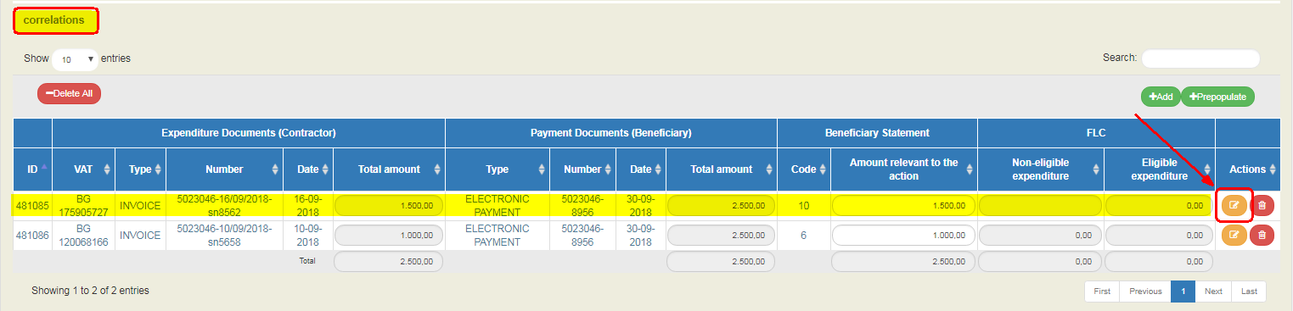
- On the pop-up window, he fills in the “Non-eligible expenditure” and the “Remarks” (1). Then he selects “Accept” (2).
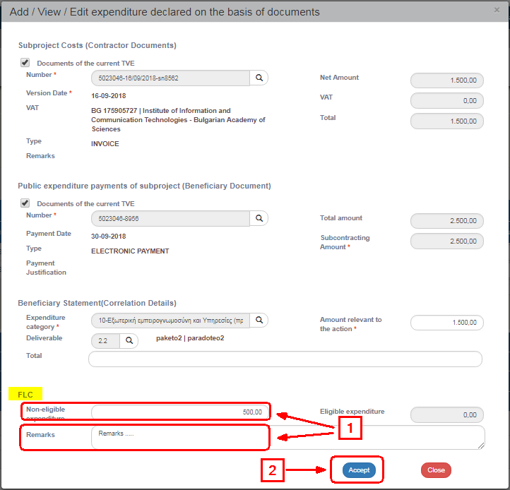
- If required, he follows the same process to enter the “Non-eligible expenditure” to another correlation.
- The “Non-eligible expenditure” are automaticaly transferred to the respective column of the Correlations table.
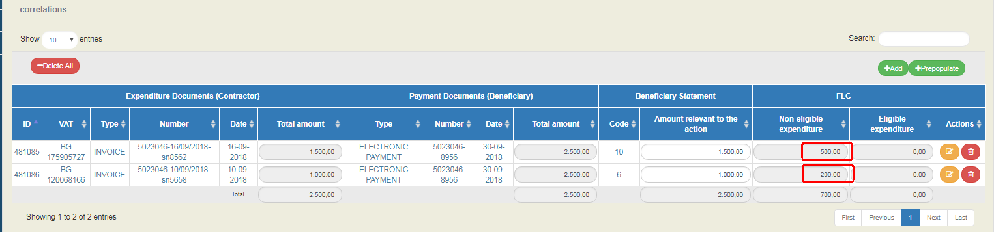
- He selects the “D. Administrative Verification” section and fills in the “Controller” field (1) and the Administrative Verification questions (2) with remarks, if any. The Correction Amount (3) appears on the “Non-eligible expenditure from Direct Expenditures” and “Total” fields.
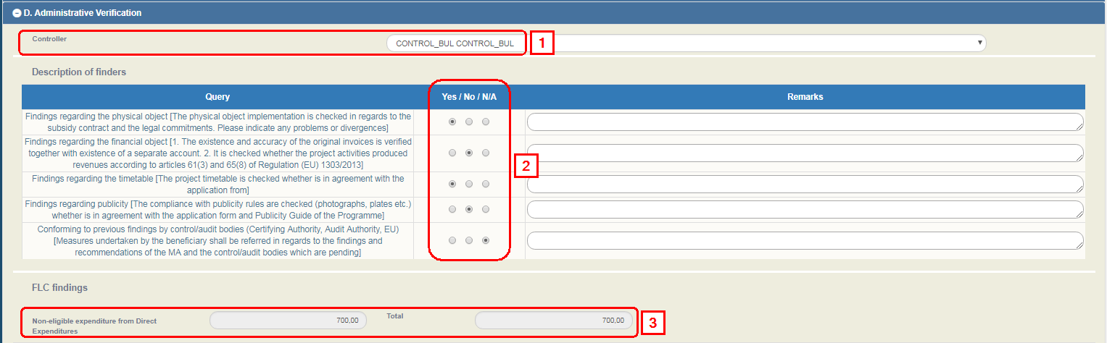
- Then he selects “Add” on the Table of Findings to match the Non-eligible expenditures to the Findings.
This process is compulsory. If the Controller omits it, the system will show a Validation Error during the validation of the Table of Expenditure.
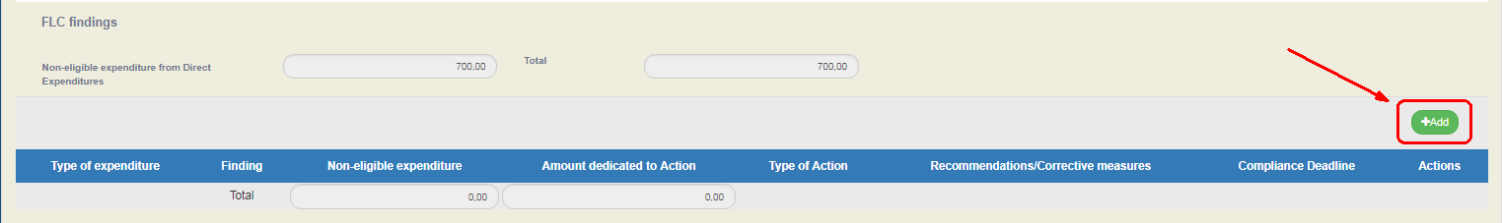
- On the pop-up window he fills in the “Type of expenditure”, “Finding” and “Non-eligible expenditure” (1), which are compulsory fields and then he fills in the “Recommendations/Corrective measures”, “Compliance Deadline” and “Remarks” (2) in needed. If required, he selects “Fraud indication” and fills in “Indication justification” (3). Finally, he selects “Accept” (4).
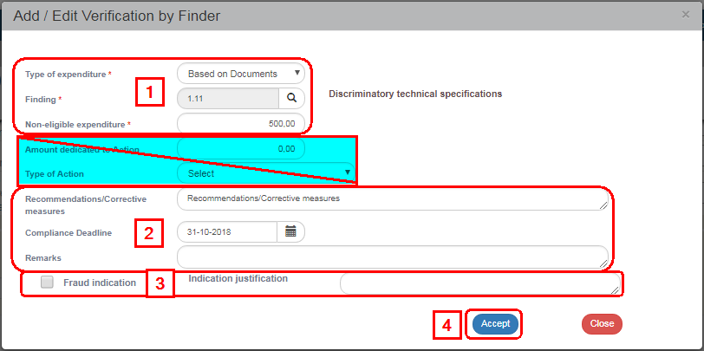
The “Amount dedicated to Action” and “Type of Action” fields do not concern the ETC Programmes (Interreg).
- He follows the same process to enter the “Non-eligible expenditure” with another finding code and selects “Close” to disactivate the window.
- The Table of Findings is updated and the User selects “Save” (3) from the tool bar (menu).
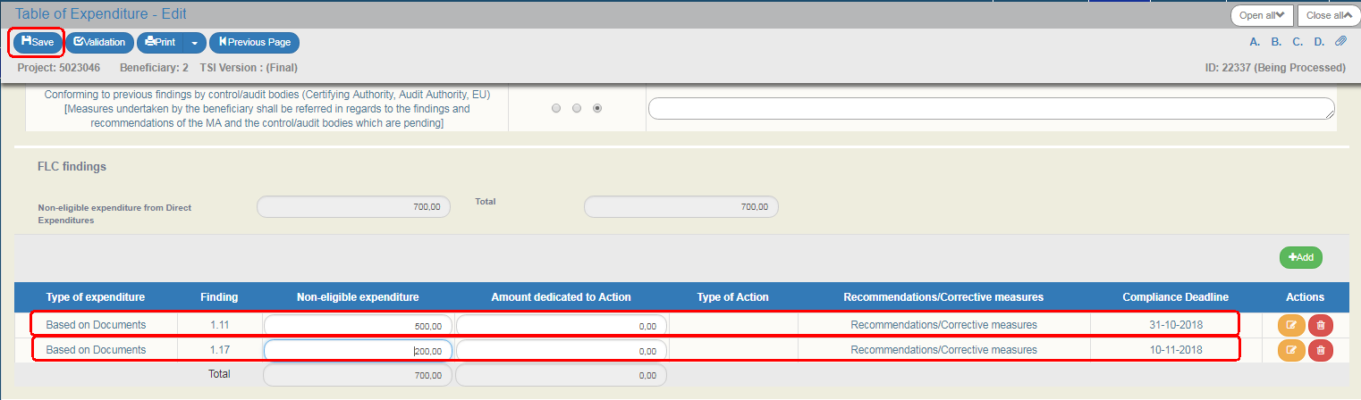
- After he finishes filling in Section D the User moves on to the:
  - "Attachments":
Section 2.5.2 of the "User Application Manual describes in detail the way to add, edit, delete and receive attachments.
  - "Change history": On the table appears the Change History of the Table of Expenditure Status (System Date and Time, Status of Table of Expenditure, User’s Name, Action Comments, E-mail recipients).
  - The "Beneficiary Entry Comments" and "MA/JS Comments" fields are used for comments by the Beneficiary and the Management Body User, respectively.
  - "Validation": If the User clicks on the Validation key from the tool bar (menu), the system performs a validation control and a pop-up window appears, which is either blank:
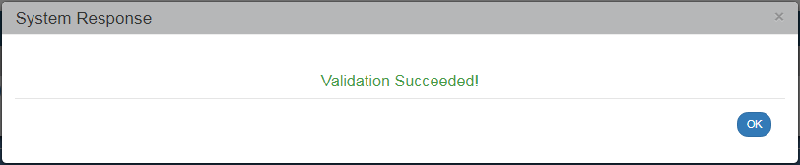
or displays errors-notifications detected.
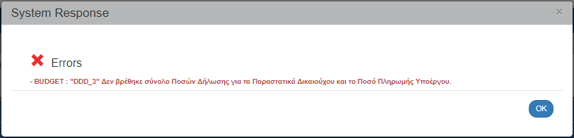
If the User clicks on "OK" he disables the window and after correcting-updating the data, he may move on to SUBMIT.
A validation control may either be an Error or a Warning. When it is an error, the system does not allow the user to move on, unless he corrects the error. When it is a warning, the User may proceed to the verification of the Table of Expenditure without previously making any corrections.
By clicking on "Print" key from the tool bar, the user has the option to print in pdf, doc and xls format:
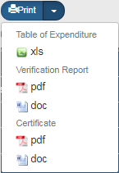
  - He selects the "Previous Page" key from the tool bar (menu) to return to the search menu.
If the User clicks on "Previous Page", the system displays the following warning message:
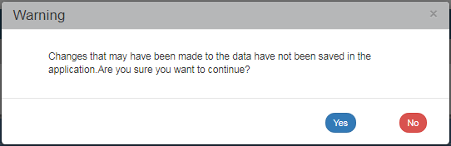
If the User enters data and does not wish to save them, he clicks on "Yes" to return to the search menu. Otherwise, he clicks on "No", saves, selects "Previous Page" and clicks on "Yes".
- The Controller proceeds to the “Verification” of the Table of Expenditure in order to make it available to the Managing Authority for approval (see Section 1.4).
The Beneficiary and the MA/IB, are informed by an automatic email by the system.

Return of the Table of Expenditure
If the Controller does not wish to intervene on the Table of Expenditure and the corrections need to be made by the Beneficiary, he selects the “Return” action following the following steps:
The “Return” action is enabled when the Table of Expenditure is in “Being processed” or in “Submitted” status.
- A search menu appears on the interface and the User makes a search of the Table of Expenditure and selects the “Return” action on the table of Search results.
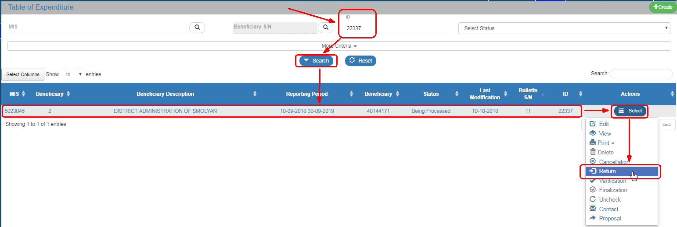
- The system displays the “Table of Expenditure-Return“ screen and the Controller selects “Return” (1) on the tool bar (menu).
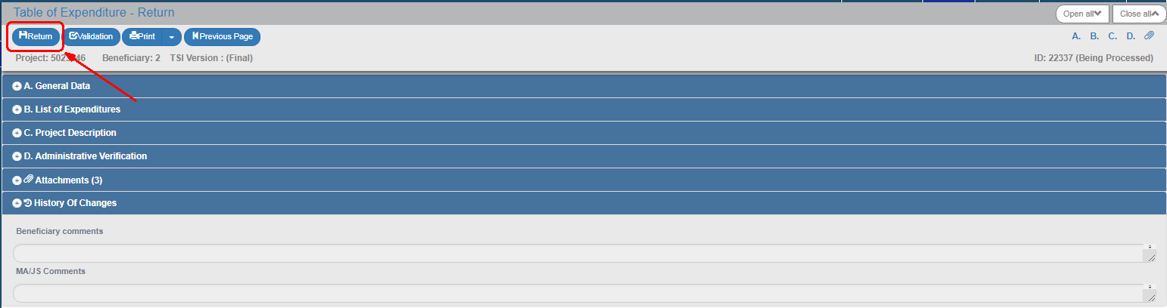
- On the pop-up window that appears, the User fills in the field with a detailed description of the cause of return and then selects “OK”.
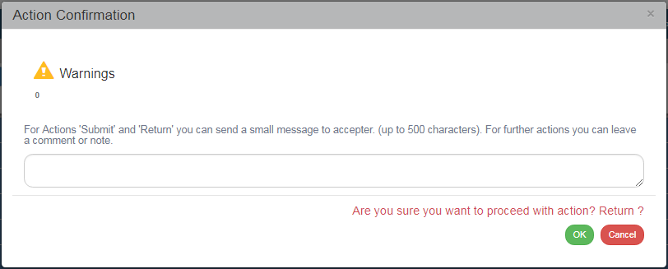
Upon its Return, the Status of the Table of Expenditure changes to “Return to Beneficiary”. Prior to any changes, the Beneficiary must save it, in order to change its status to “Under Submission”. After making all changes, he must re-submit the Table of Expenditure.

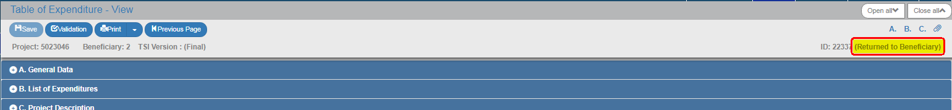

When the Table of Expenditure is in “Return” status, the Controller cannot edit it.

Table of Expenditure Verification
After completing his task (Table of Expenditure with or without “Non-Eligible Expenditure”), the Controller proceeds to the “Verification” of the Table of Expenditure in order to make it available to the “Managing Authority” through the following steps:
- A search menu appears on the interface and the User makes a search of the Table of Expenditure and selects the “Verification” action on the table of Search results.
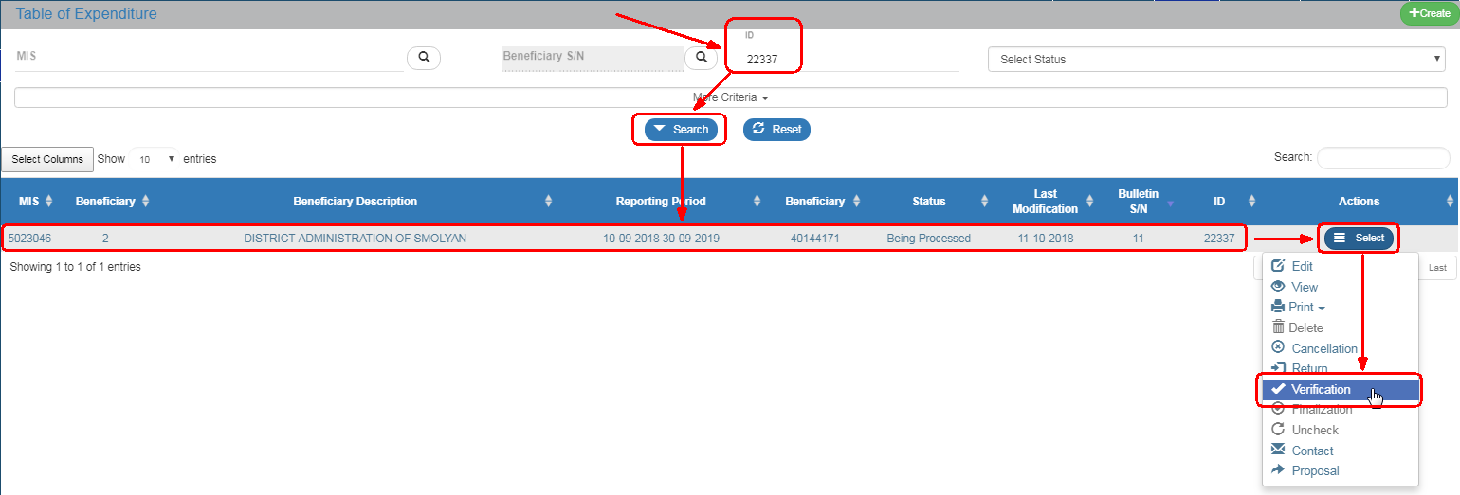
- The system displays the “Table of Expenditure - Verification“ screen and the Controller selects “Verification” (1) on the tool bar (menu).
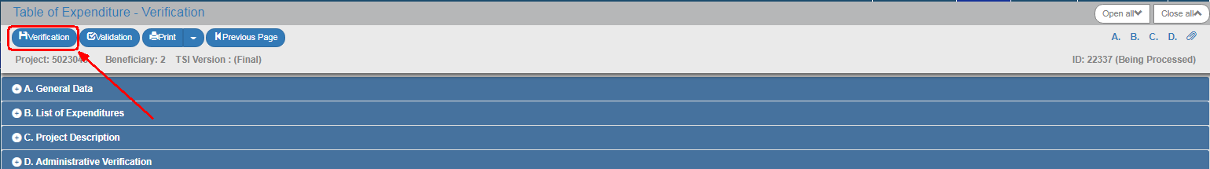
- On the Confirmation pop-up window, the Controler selects “OK”.
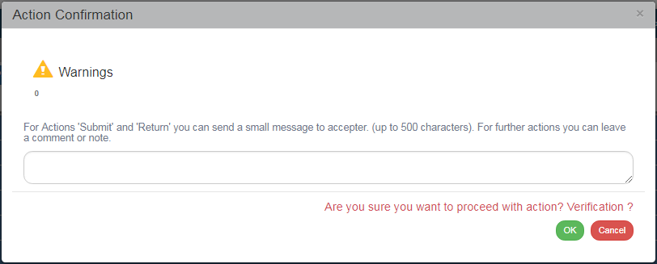
After Verification, the status of the Table of Expenditure changes to “Verified”, and the MA User is informed by an automatic email by the system to finalize the Table of Expenditure. Finalizing (Approval) a Table of Expenditure is only possible for “Verified” Tables of Expenditure.
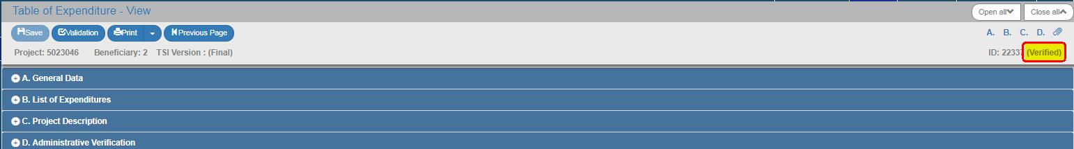

Communication
The Controller has the possibility to communicate with the Beneficiary through the respective action, through the following steps:
- A search menu appears on the interface and the User makes a search of the Table of Expenditure and selects the “Contact” action on the table of Search results.
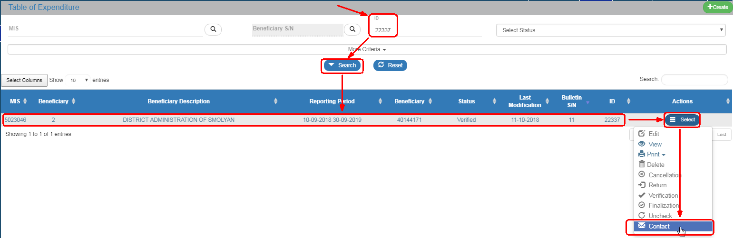
- The system displays the “Communicate” screen indicating the ID of the relevant Table of Expenditure. The User fills in the “Subject” and “Text” (2) mandatory fields. On the “Extra Emails” field (3), the User has the possibility to add more recipients to the existing ones.
If he adds many recipients, he shall separate them by a comma (,) - see instruction in .
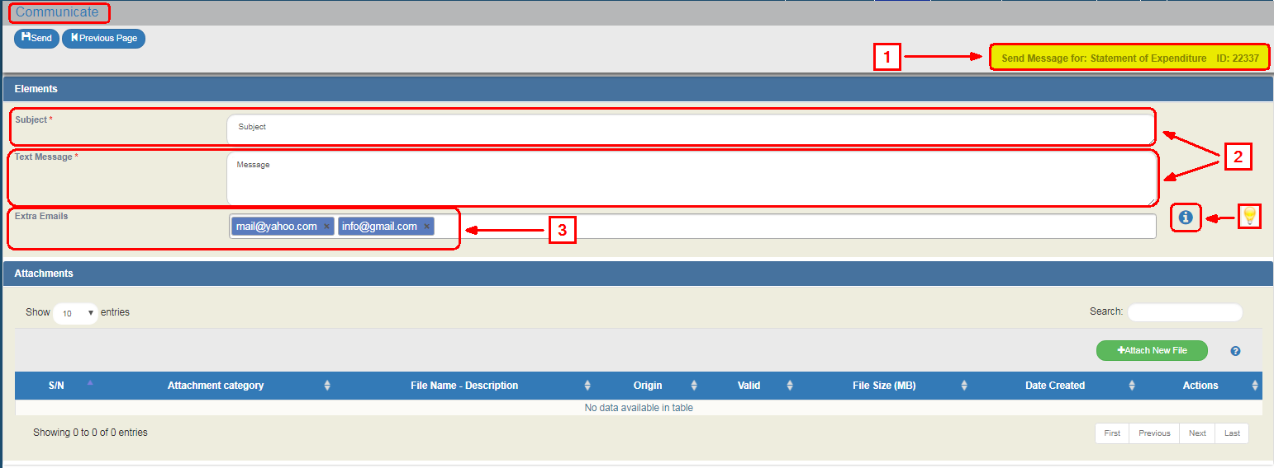
- The user adds attachments to the respective section of the screen, which are added automatically by the system to the attached documents of the “Table of Expenditure” module (Screen).
Section 2.5.2 of the User Application Manual describes in detail how to add, edit, delete and receive attachments.
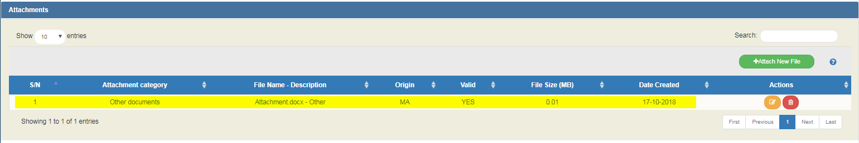
- The User selects “Send” from the tool bar (menu).
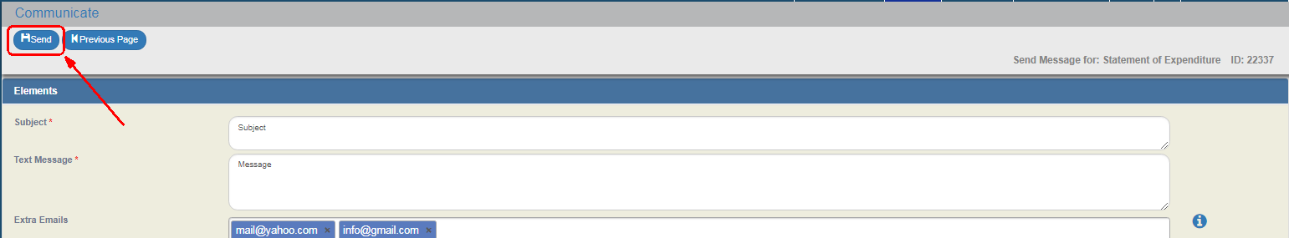
- An email is sent to the “Beneficiary” and “MA” Users and to the additional recipients through the following text:
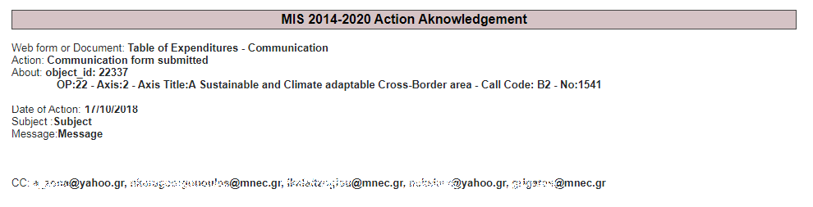

ETC Table of Expenditure Actions
The following table describes all the actions that appear on the pop-up list of the "Actions" column on the Table of Results of the search menu. Depending on the ToE status and the User’s rights/competences, some actions of the system are enabled.

ACTION | INTERPRETATION
The ToE Edit key allows the User to recover the Table in order to enter and edit data.
After completing the Create actions (New Table of Expenditure) the title on the screen changes to Edit.
Through the ToE View key, the User recovers and views a Table without the possibility of entering and/or editing its data.
After performing the Submit, Discard, Cancel, Return, Finalization and Undo actions, the form status changes from Create to Review.
 | It allows the User to Print a table of expenditure in xls form
 | The Delete action deletes permanently a Table from the system. After clicking on Delete, the User is taken to the screen search to search for a Table. Deleting a Table is only possible when it is in ‘Under Submission’ status and fulfils some requirements e.g. it has not yet been submitted, returned etc.
 | The ‘Cancel’ action does not delete the Table from the system but its status changes to Invalid/Disabled and the User can recover it with Review. The action is not valid for the Table of Expenditure.
 | Through the Finalization -Table of Expenditure control (reserved to the Managing Authority/JS), the User performs the final control and ‘locks’ the Table, in order to inform the Certification Authority that it is ready to be included in a payment request.
Through the ‘Uncheck Table of Expenditure’ action (reserved to the Managing Authority/JS), it is possible to undo finalization (uncheck) in a Finalized Table which changes status to ‘Being processed’. Unchecking a Table of Expenditure is only possible for Tables that do not have any dependent Tables of Expenditures.
Also ‘Uncheck’ is possible for Tables ‘Returned to the Beneficiary’. The Table status changes to ‘Being processed’ (for the Controller).
 | By clicking on the Table Submission/Intermediate Body (reserved to the Beneficiary) the User submits the Table to the Managing Authority/JS.
 | Through the Table of Expenditure return action (reserved to the user Controller), the ToE goes back to the Beneficiary for corrections.
 | It consists of a two-way communication between the Managing Authority/JS or the Controller and the Beneficiary, in the form of texts and attachments sent to make a request or ask for additional information.
 | This action (reserved to the user Controller) consists of verifying and forwarding the Table of Expenditure to the relevant bodies.

