

**MINISTRY OF ECONOMY AND DEVELOPMENT**

**GENERAL SECRETARIAT FOR PUBLIC INVESTMENTS & NSRF**

**NATIONAL COORDINATION UNIT**

**SPECIAL SERVICE FOR THE MONITORING INFORMATION SYSTEM**

***Implementation of the Monitoring Information System (MIS)***

***In compliance with the requirements of the Programming Period***

***2014 -2020***

***Electronic System for the monitoring of nsrf programmes and projects***

***USER’S MANUAL (Beneficiary)***

***Project MONITORING TABLE OF EXPENDITURE***

***(EUROPEAN territorial cooperation programmes)***

***Version: 01.00***

TABLE OF CONTENTS

TABLE OF CONTENTS 4

1. ETC Table of expenditure 5

1.1 Creation of an ETC Table of expenditure 5

1.1.1 Section "B. Declared Expenditure based on Supporting Documents" 6

Α. Introduction 6

Β. Document Entry 7

C. Entry of correlations 10

1.2 Searching a ETC Table of expenditure 18

1.3 ETC Table of expenditure inputs 20

# ETC Table of Expenditure

## Create an ETC Table of Expenditure

1. Enter the Electronic System for the monitoring of nsrf programmes and projects (see Section 2.1 of the manual "Application Interface").
2. From the Main Menu of the Electronic System for the monitoring of nsrf programmes and projects select the path: (1) ΕΤC → (2) Monitoring → (3) Table of Expenditure (ToE).

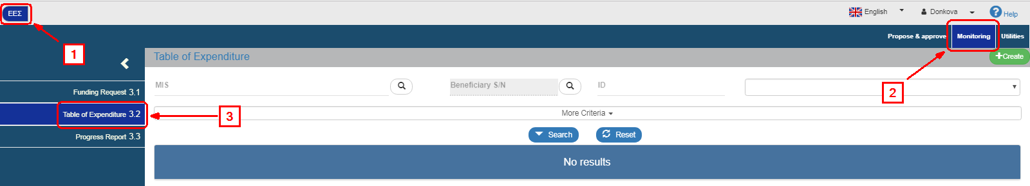

1. On the interface appears the ToE search screen. To create a new Table, the user selects "Create".

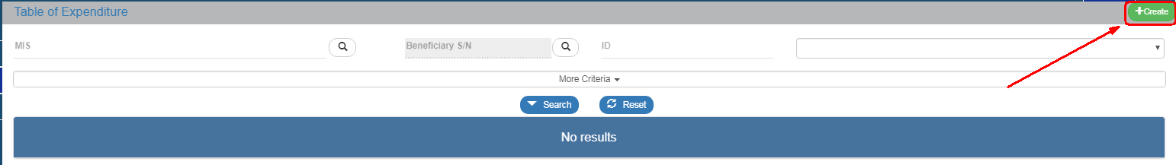

1. A pop-up window appears.

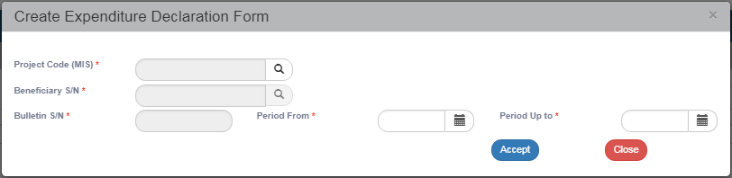

On the window, the user must select or fill the MIS code of the project (1). After entering the MIS code, the user clicks on the search button (lens) to search for a Partner (2). Then the system fills in automatically the Table’s S/N (3) indicating the Table S/N for this specific Partner.

Finally, the user fills in the dates in the fields "Period From" to "Period Up to" (4).

 Now then, the Table reports a period with incurred/paid expenditure and not a specific month of a year. The period is established by the user taking into account the documentation that will be entered in the system. The payment documentation of the Beneficiary must fall into the period from cell "Period From" to cell "Period Up to". The User can modify the dates "From" to "Up to" when editing the Table.

After entering the above data, the User selects "Accept" (5) and the entry screen appears. If the user clicks on "Close"  the creation of the Table of Expenditure is canceled.

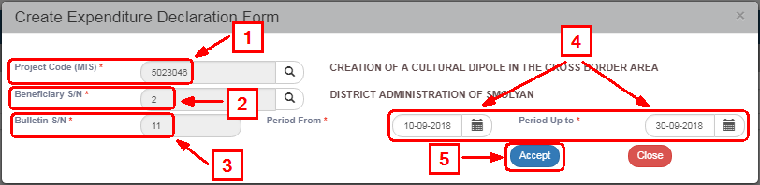

1. The system displays the new entry screen "Table of Expenditure – Create" and pre-fills the "A. General Data" section in the Create pop-up window. The user fills in the beneficiary’s full name, as displayed on the figure below.

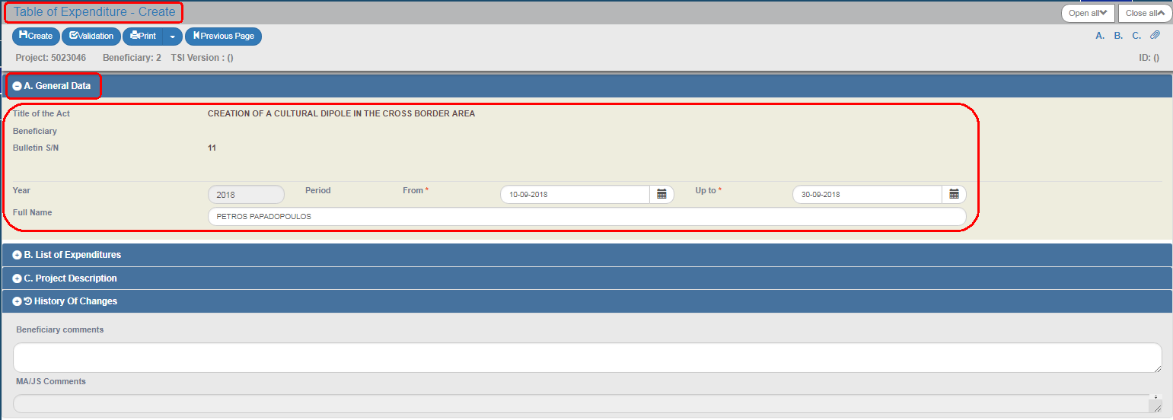

1. Select the "Create" key  from the tool bar (menu).

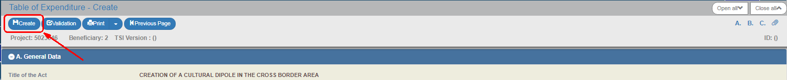

1. A Save message appears. Click on "OK" to close the message and return to the screen.

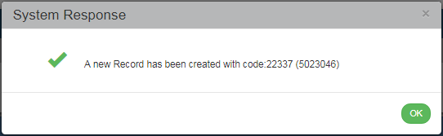

 The system:

* + - 1. Assigns the unique identification number (id) and the "Under Submission" status to the Table of Expenditure.
      2. The "Table of Expenditure - Create" changes to "Table of Expenditure - Edit" and the "Create" key is replaced by the "Save" key.

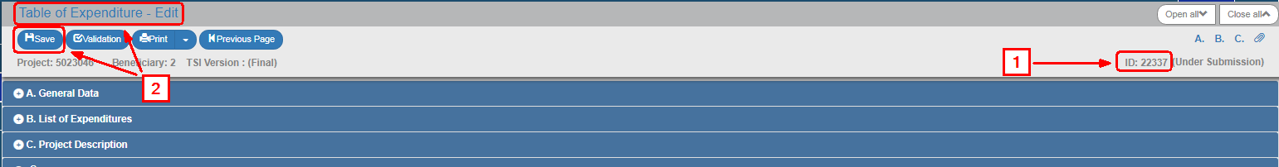

 If the user does not proceed to the "Creation" of a Table (1st Save), the system does not enable the option of entering data in the following sections.

### Section "B. Declared Expenditure based on Supporting Documents"

#### Α. Overview

The section "Β. Declared Expenditure based on supporting documents" consists of two tables, the **Documents** and the **Correlations** tables.

On the Documents table, the User enters both Expenditure (Contractor’s documents) and Payments (Beneficiary’s documents). Every document is entered on this table **ONLY ONCE.**

On the Correlations table, the user correlates Expenditure with Payments.

 **If the Documents (of the Contractor or the Beneficiary) have already been entered in a previous Table of Expenditure, there is no need to re-enter it on the current Table of Expenditure . If it is required tobe used in a correlation, there is a search/entry option on the pop-up “Add Correlation” window (see section C.1 of the present).**

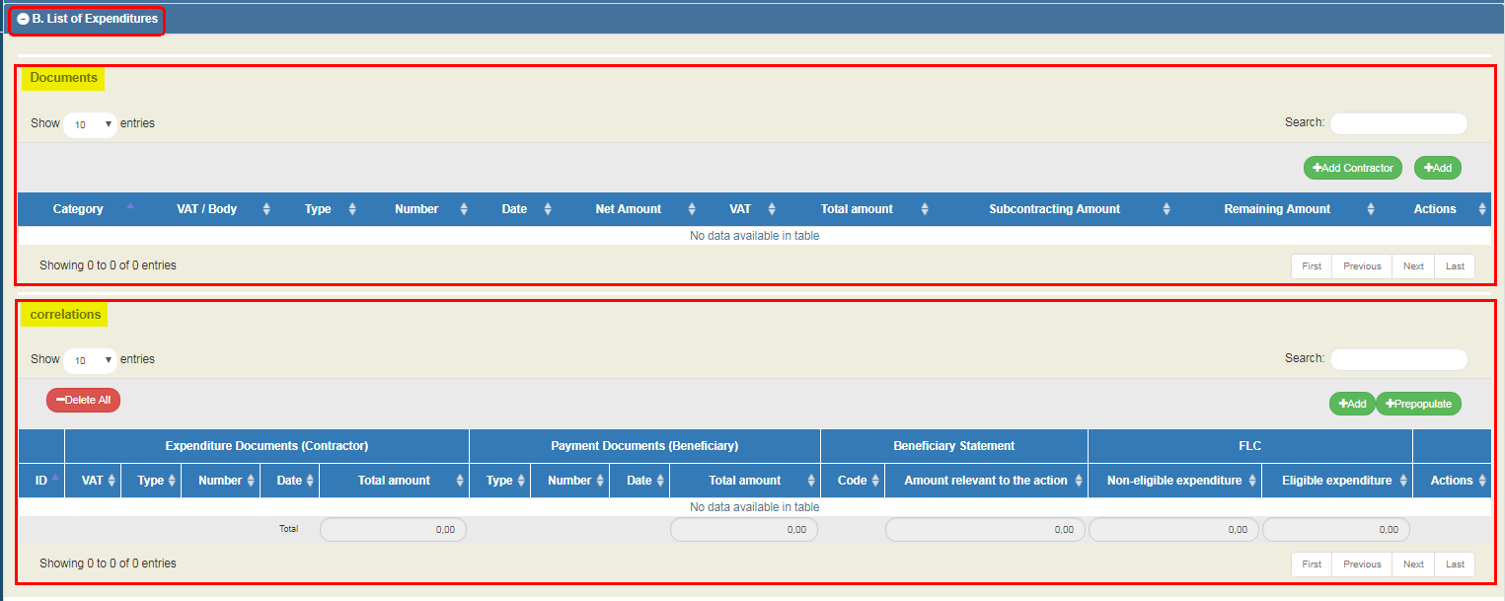

#### Β. Documents Entry

1. The User selects "Add" on the Documents Table and a pop-up window appears. From the "Document Category" drop down list, the User selects "Expenditure" (Contractor Document).

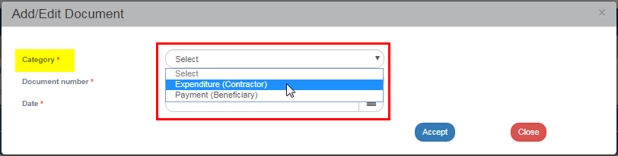

1. After selecting the Expenditure document (Contractor), except from the Document Number and Date, the following fields appear on the pop-up window: Code of Type, VAT/Body, Net amount, VAT, Total and Remarks. The User is required to fill in the mandatory fields (marked with asterisk (*)) as shown on the figure below.

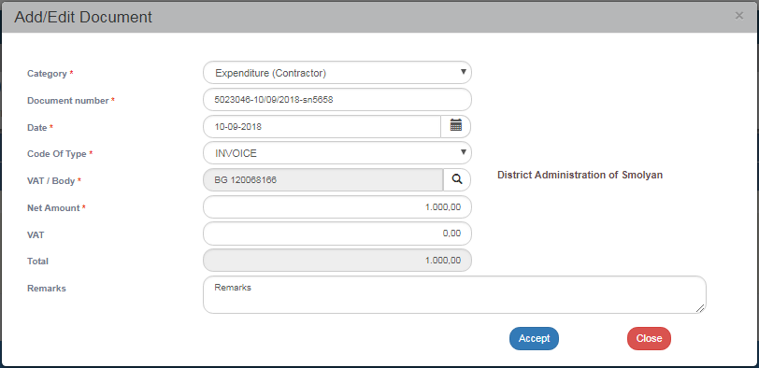

1. The User selects "Accept"  to enter the data on the table and the pop-up window becomes blank again for the next entry. The same procedure is followed for the rest of the Expenditure Documents (Contractor).

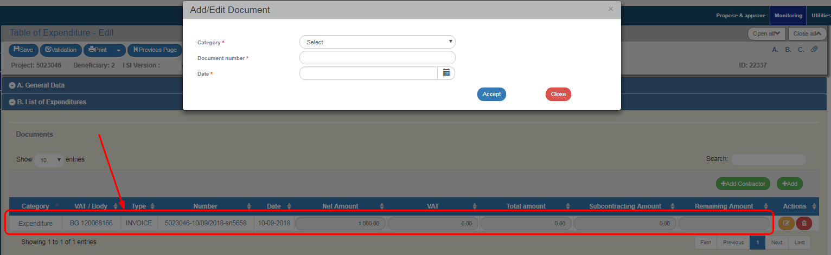

1. When the User finishes entering the Expenditure documents (Contractor), he moves on to the same table and enters the Payment documents (Beneficiary) by selecting from the "Document Category" drop-down list, the value "Payment" (Beneficiary Document).

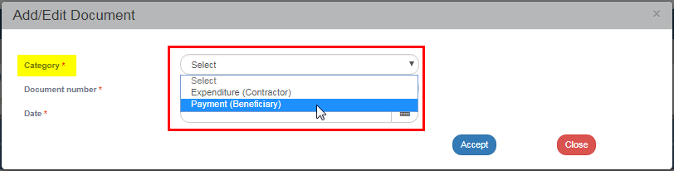

1. After selecting the Payment document (Beneficiary), except from the Document Number and Date, the following fields appear on the pop-up window: Code of Type, Total Amount, Sub-contracting amount and Payment Justification. The User is required to fill in the mandatory fields (marked with asterisk (*)) as shown on the figure below.

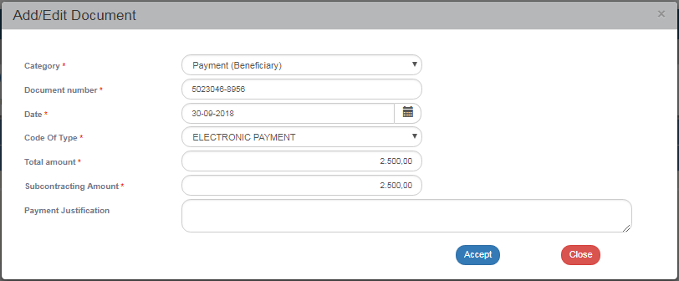

1. When the User finishes entering the Payment documents (Beneficiary), he/she selects "Accept" to enter the data on the table and then "Close"  to disable the pop-up window and return to the Table. In this example, three entries were made on the Documents table; two of them are "Expenditure" and one is "Payment" intended for paying off the two Expenditures.

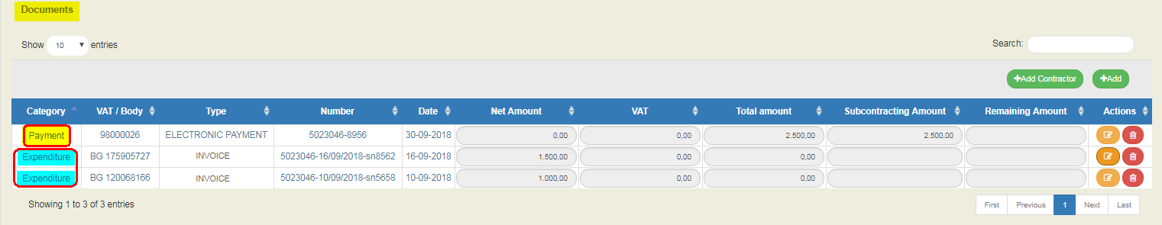

**On the Documents table, only documents that were entered in the current Table of Expenditure appear. If there is a need to be correlated with documents that were entered in a previous Table, it is possible to search the document on the pop-up ‘Add Correlation’ window (see Section C.1. herein).**

** Every Payment document (Beneficiary) and Expenditure document (Contractor) is entered once on the Documents table, even if it is then used for more Correlations.**

** Expenditure and Payment Documents may be used in one or more correlations on the Correlations Table.**

** Expenditure and Payment Documents may be used in more than one projects..**

** The values "Net Amount", "VAT", "Total amount" and "Sub-Contracting amount" may be modified on the Documents table at any moment. If the documents have been correlated, the Correlation Table is also automatically updated after clicking on save.**

Section 2.5.1 of the "Application Interface" Manual describes in detail the way to add, edit and delete data on an application table.

1. After completing filling in the table, the User selects "Save"  from the tool bar (menu).
2. When entering the Expenditure document (Contractor) on the Add Document pop-up window, and, more specifically, on the VAT body field, the (VAT) value that the User wishes to select may not be enabled. In such case, he must close the Add Document window and click on the "Add Contractor" key. On the pop-window that appears, he checks the "Greek VAT" check box, if he wishes to enter a VAT of a Contractor from Greece, otherwise, the check box remains unchecked. The user then enters the VAT, the Tax Office (taxation office) and the rest personal data. Note: In case of a Greek VAT/Body number, the data on the Form may be automatically filled in. The User types the VAT number and then clicks on "Updating data from TAXIS". After he finishes filling in the data, he clicks on "Accept".

**The user must first Save the Table of Expenditure in order for the new VAT number to appear on the value list of the VAT field on the pop-up "Add Document" window.**

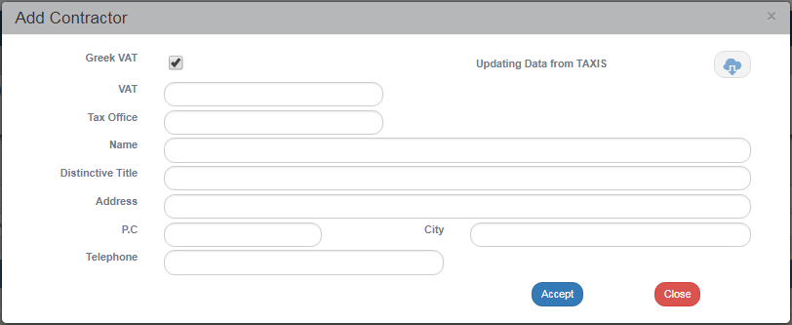

#### C. Entry of correlations

1. After entering the Expenditure and Payment documents, the User proceeds to their correlation on the Correlation table. He selects "Add"  on the Correlations Table and a pop-up window, divided into three parts, appears: "Project Costs (Contractor Documents)", "Public Expenditure payments of project (Beneficiary Document)" and "Beneficiary Statement (Correlation Details)" as shown below:

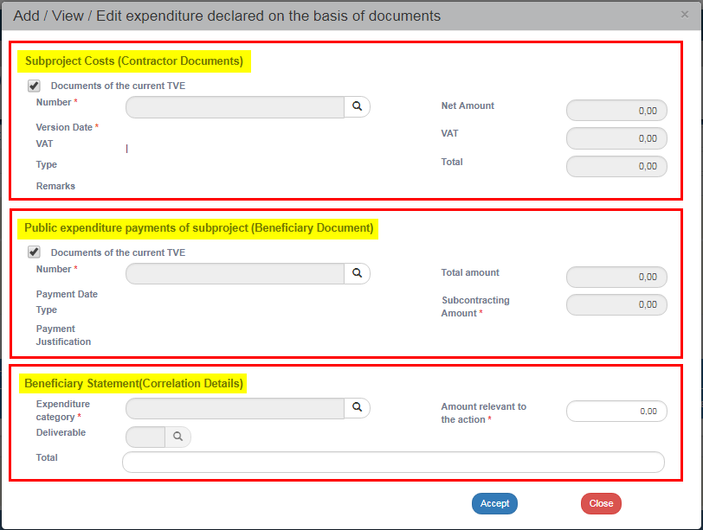

1. The User selects the documents from a value list in order to create correlation of payment. When the check box "Documents of the current Table of Expenditure is checked  , only the documents created in the current Table appear on the value list. If the user unchecks the "Documents of the current Table of Expenditure" check box  , the search icon (magnifying lens) for selecting a document, will display documents from previous Tables of Expenditure.
2. The User clicks on the lens of the "Number" field to search the Expenditure document (Contractor).

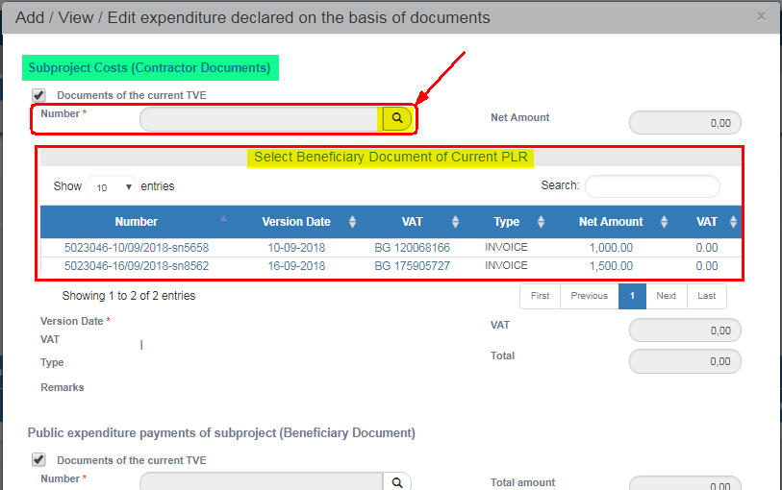

1. Then the user clicks on the lens of the "Number" field to search for a Payment document (Beneficiary).

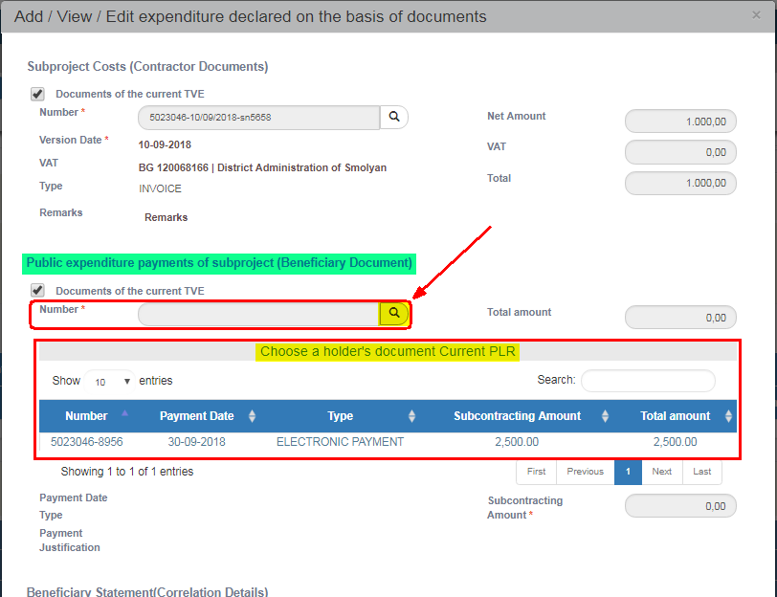

1. After selecting the Expenditure and Payment documents, the user enters the Payment Correlation Details, filling in the "Expenditure Category", the "Deliverable" and the "Amount relevant to the action".

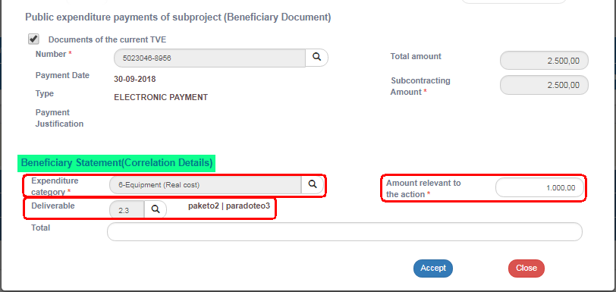

1. The User selects "Accept"  to enter the data on the Correlations Table and the pop-up becomes blank again for the next correlation. He carries on selecting the second Expenditure and the same Payment, which, in this example pays off the two Expenditures.
2. After the User completes the two correlations, he/she selects "Close" to disable the pop-up window and return to the Table.
3. After the User finishes completing the table, he/she selects "Save" from the tool bar (menu) and the system assigns a unique (id) to each correlation.

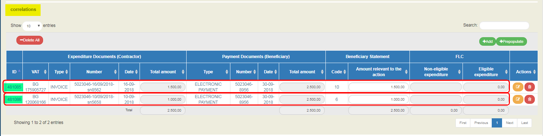

** The "Beneficiary Statement | Amount" value may be modified either on the pop-up window using the edit key or on the Correlations table on the main menu of the Table.**

**In case that a Payment document (Beneficiary) is correlated with another sub-project, the Amount for the current sub-project must be updated in the first correlation that will be used.**

**Section “C. Detailed description” is not completed by the beneficiaries**

1. After completing filling in Section B, the User moves on to the:
   1. "Attachments":

Section 2.5.2 of the manual "Application Interface" Manual describes in detail the way to add, edit, delete and receive attachments. More specifically:

To attach a new file, the User selects "Attach a new file"  in the relevant section of the Table.

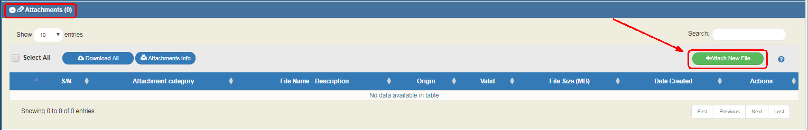

A pop-up window appears and in Section "Step 1: Select the file from your computer that you need to attach", the User selects "choose file" 

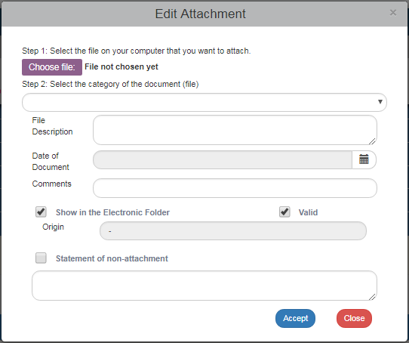

In the pop-up window that appears conformable to the User’s operational system, the User makes a search and attaches the File of his/hers choice.

The User moves on to the 2nd step "Select the document category (file)",

After selecting from the pop-up list the desired document category (1), he/she fills in the other fields (2) and then clicks on "Accept"  (3).

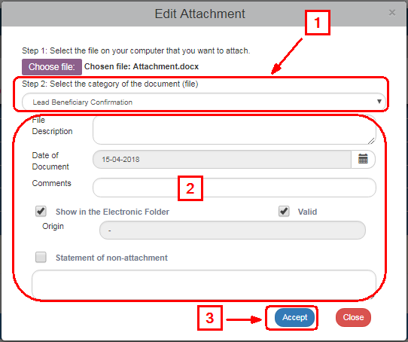

The "Show in the electronic folder" and "Valid" check boxes are reserved to the Managing Authority. The Statement "Non-attachment” " must be accompanied by a justification on the grounds of non-attaching a necessary file.

The system returns to the main menu, where the file (1) has been added to the table of attachments. Also, next to the title "Attachments" there is a number indicating the number of attachments on the screen (2). The symbol  is a link to the "NSRF 2014-2020 Announcements" (3).

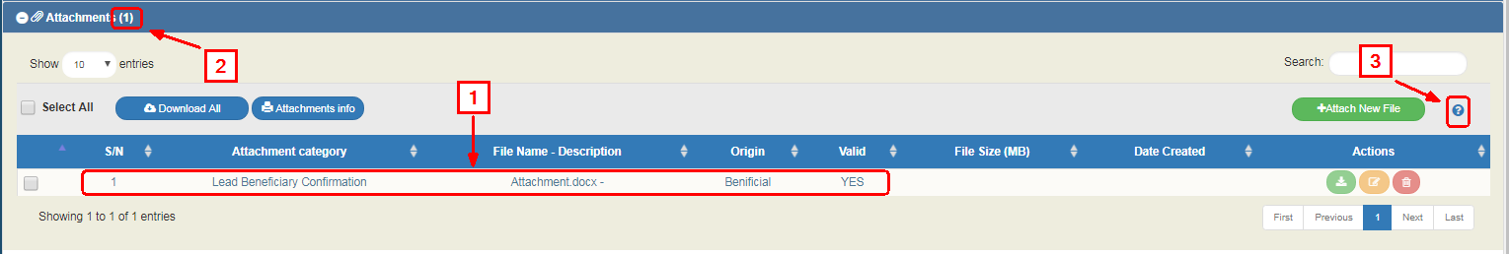

On the table of attachments (1), there is information about the attachments such as the File Name, the Document Category, the Origin of the Documents, its size etc.

**Downloading attachments**

To download an attachment from the Table of Attachments, select "Download file" 

The browser displays a message for opening or saving the file in the computer and the User can choose the file name and the location in his computer to store it.

To download more files, the User chooses the files that he/she wishes to download using the check boxed on the first column (1). To download all the files, he/she can choose the "Select All" (2). Then, using the function "Download All" (3), he/she stores all the selected files in his/her computer. Through the "Attachments Details" function, the User can print a summary of the Table Documents (4).

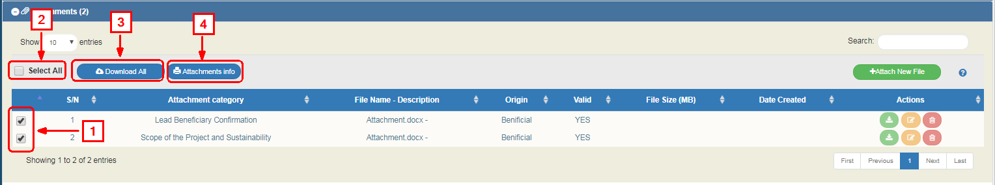

**Edit & Delete attachments**

To edit an attachment, the User selects the Edit function on the table, while to delete an attachment, he/she selects the Delete function

 **Any file attached by the beneficiary must not be over 10MBs. In every Table of Expenditure, the total size attachments must not be over 50MBs. For larger files, the beneficiaries must use online applications (e.g. WeTransfer).**

* 1. "Change history": On the table appears the Form Status Change History (System Date and Time, Form Status, User’s Name, Function Comments, E-mail recipients).
  2. The "Beneficiary Entry Comments" and "Managing Body Entry Comments" fields are used to enter comments by the Beneficiary and the Managing Body User, respectively.
  3. "Validation": If the User clicks on the Validation  key from the tool bar (menu), the system performs a validation control and a pop-up window appears, which is either blank:

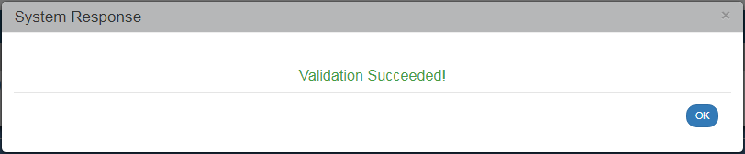

or displays errors-notifications detected.

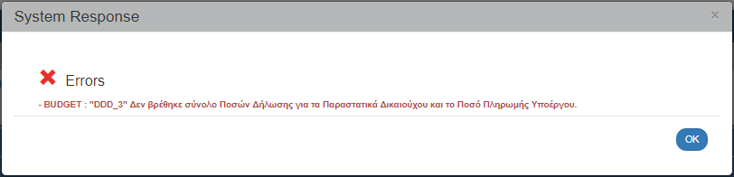

If the User clicks on "OK", he/she disables the window and after correcting or updating the data, he/she may move on to SUBMIT.

* 1. By clicking on "Print" key  from the tool bar, the user has the following printing options in pdf, doc and xls.

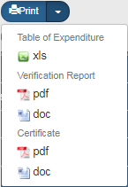

* 1. Click on the "Previous Page"  key from the tool bar (menu) to return to the search menu.

If the User clicks on "Previous Page", the system displays the following warning:

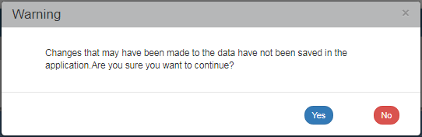

If the User has entered data and does not wish to save then, he/she clicks on "Yes" to return to the search menu. Otherwise, he/she clicks on "No", saves, selects "Previous Page" and clicks on "Accept".

1. After filling in the form, the User must submit a request in order for the form to became available to the Managing Authority for final approval.,.

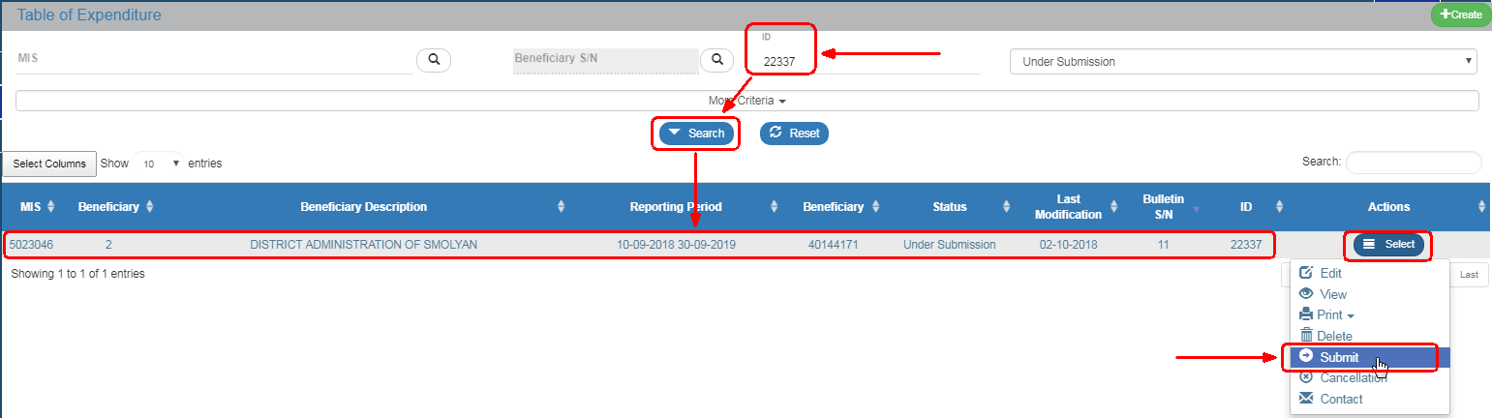

Section 2.6 of the "Application Interface" Manual describes in detail the way to SUBMIT a form. More specifically:

On the screen menu of a form, as specified in Section 1.2 and on the Table of Results, there is a column entitled "Actions".

By clicking on "Select"on the selected row, a pop-up list appears, Enabled or Disabled depending on the Form’ status and the User’s rights and competences.

**Submission of the Table of Expenditure by a beneficiary**

If a Beneficiary wishes to submit a Table of Expenditure, he/she selects "Submit" from the pop-up list and the system diverts to the screen entitled "Table of Expenditure - Submit" with the relevant "Submit" option , as displayed on the following figure:

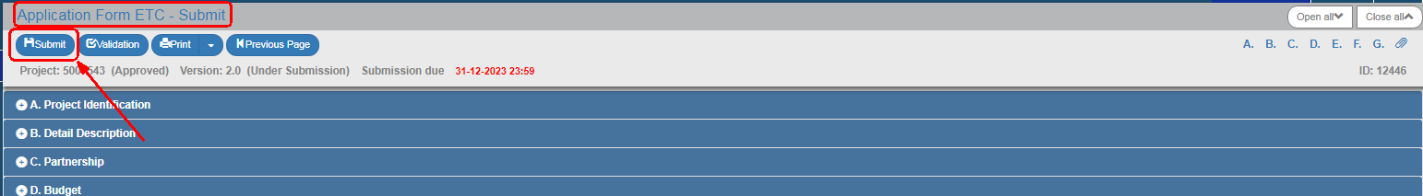

By clicking on "Submit", the system carries out logical validation controls and displays:

* Either error messages (which require a correction) and warnings (it is to the User’s discretion to make or not corrections) detected in the Table.

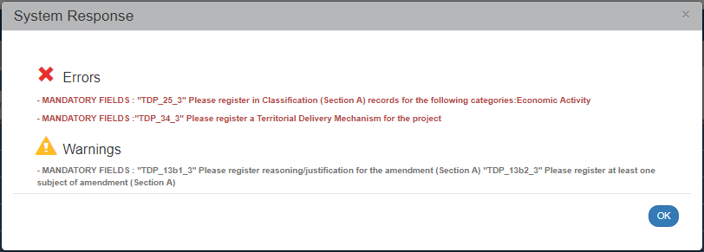

* Or an "Action Confirmation" message, wherein the user enters text comments addressed to the FL controller, and then he/she clicks on "OK" to complete the Table submission.

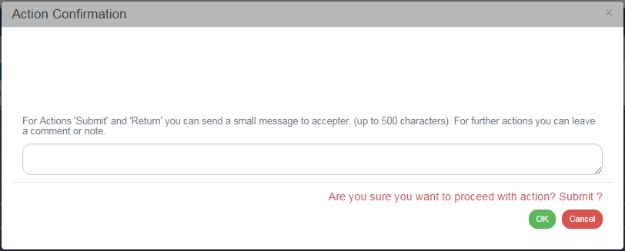

The system returns the Table status to "Submitted". The Beneficiary has no longer the option to edit the “Table of Expenditure” because it has been submitted to the FL controller. While the “Table of Expenditure” is being processed by the FL controller, the Beneficiary can only view the Table of “Expenditure” through "Select-print" menu.

## Searching an ETC Table of Expenditures

 Consult the "Application Interface" Manual (Section 2.3) which provides a detailed description of the search menu operation, which is common for all system operations.

1. From the Main Menu of the Electronic System for the monitoring of NSRF Programmes and Projects select the path: (1) ΕΤC → (2) Monitoring → (3) Table of Expenditures (ToE).



1. On the working screen , the ToE search screen appears together with the "main" search criteria, as shown on the figure below,

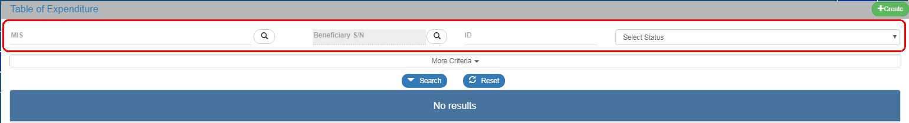

* Project Code (MIS): The User may either click on the search icon (lens) to obtain a value list or type directly in the MIS field, if the Code is already known.
* Beneficiary S/N: A value list appears when clicking on search icon (lens). When selecting the Project Code (MIS), a list of Beneficiaries correlating to the selected MIS code, appears.
* ID: This is the unique MIS number of this Table. As stated in Section 1.1, the ID is assigned directly to the Table by the System, upon Table generation.
* Select Status: A pop-up list with the following categories appears:

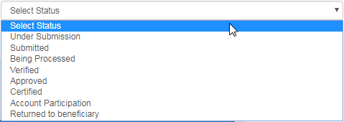

1. By clicking on "More criteria" the following "Additional" criteria screen appears:
2. 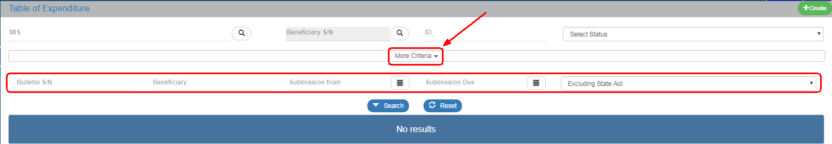

* Table of Expenditure S/N: Numerical field
* Beneficiary S/N: Numerical field
* Submission from: Date field
* Submission to: Date field
* Pop-up list with the following categories:

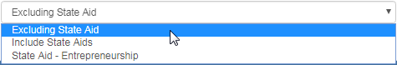

1. The User performs a “search”.
2. When the search is completed, the corresponding to the “search” results appear on the Table of Expenditure:

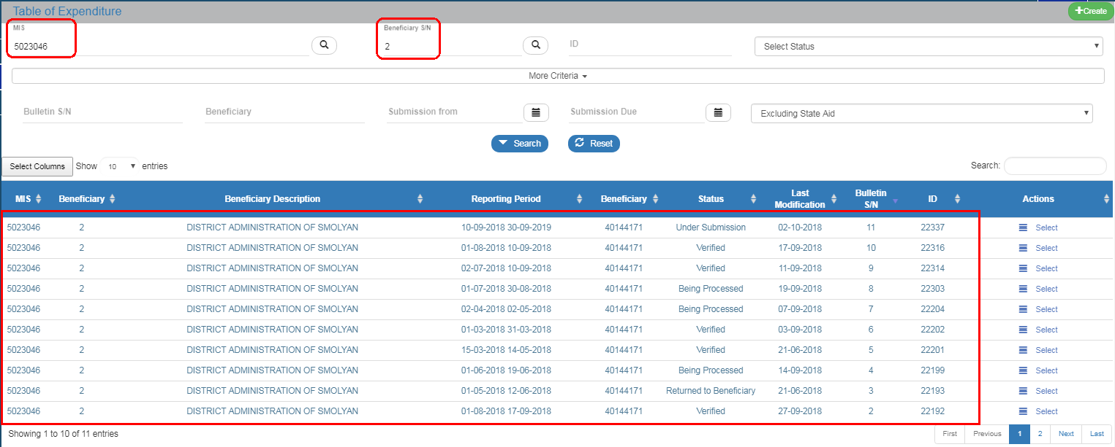

## ETC Table of Expenditure Actions

The following table describes all the actions that appear on the pop-up list of the "Actions" column on the Table of Results of the search menu. Depending on the ToE status and the User’s rights/competences, some actions of the system are enabled.

|  |  |
| --- | --- |
| **ACTION** | **INTERPRETATION** |
|  | The ToE Edit key allows the User to recover the Table in order to enter and edit data.  After completing the Create actions (New Table of Expenditure) the title on the screen changes to Edit. |
|  | Through the ToE View key, the User recovers and views a Table without the possibility of entering and/or editing its data.  After performing the Submit, Discard, Cancel, Return, Finalization and Undo actions, the form status changes from Create to Review. |
|  | It allows the User to Print a table of expenditure in xls form |
|  | The Delete action deletes permanently a Table from the system. After clicking on Delete, the User is taken to the screen search to search for a Table. Deleting a Table is only possible when it is in ‘Under Submission’ status and fulfils some requirements e.g. it has not yet been submitted, returned etc. |
|  | The ‘Cancel’ action does not delete the Table from the system but its status changes to Invalid/Disabled and the User can recover it with Review. The action is not valid for the Table of Expenditure. |
|  | Through the Finalization -Table of Expenditure control (reserved to the Managing Authority/JS), the User performs the final control and ‘locks’ the Table, in order to inform the Certification Authority that it is ready to be included in a payment request. |
|  | Through the ‘Uncheck Table of Expenditure’ action (reserved to the Managing Authority/JS), it is possible to undo finalization (uncheck) in a Finalized Table which changes status to ‘Being processed’. Unchecking a Table of Expenditure is only possible for Tables that do not have any dependent Tables of Expenditures.  Also ‘Uncheck’ is possible for Tables ‘Returned to the Beneficiary’. The Table status changes to ‘Being processed’ (for the Verifier). |
|  | By clicking on the Table Submission/Intermediate Body (reserved to the Beneficiary) the User submits the Table to the Managing Authority/Intermediate Body. |
|  | Through the Table of Expenditure “return” action (reserved to the user Controller), the ToE goes back to the Beneficiary for corrections. |
|  | It consists of a two-way communication between the Managing Authority/JS or the Controller and the Beneficiary, in the form of texts and attachments sent to make a request or ask for additional information. |
|  | This action (reserved to the user Controller) consists of verifying and forwarding the Table of Expenditure to the relevant bodies. |