MINISTRY OF ECONOMY AND DEVELOPMENT

GENERAL SECRETARIAT FOR PUBLIC INVESTMENTS & NSFR

NATIONAL COORDINATION UNIT
SPECIAL SERVICE FOR THE MONITORING INFORMATION SYSTEM

Implementation of the Monitoring Information System (MIS)
in compliance with the requirements of the Programming Period
2014 -2020

Electronic System For The Monitoring of NSRF programmes and projects

USER’S MANUAL
Application Manual
(ETC)

Version: 01.00

TABLE OF CONTENTS

1. Application Interface 5
1.1 How to log on to the System for the monitoring of NSRF programmes and projects 5
1.2 Monitoring System Main Screen 6
1.3 Table of Expenditure Search Screen 7
1.3.1 Fields with Search lens (Value List) 8
1.3.2 Fields with drop-down list 9
1.3.3 Table of results 9
1.4 Generating Table of Expenditures 11
2.4.1 Generating a new Table of Expenditure 11
2.4.2 Generating a New Version: 12
2.4.3 Generating through Copy 13
1.5 Detailed Screen of the Table of Expenditure 13
1.5.1 Grids 14
Entering data on a grid 14
Editing data on a grid 15
Deleting data on a grid 16
Other options on the table 16
1.5.2 Attaching Documents (Attachments) 16
Downloading attachments 18
Editing & Deleting attachments 18
1.5.3 Change history 18
1.6 Table of Expenditure- related Actions 20
Table of Expenditure submission by a beneficiary 20

Application Interface

How to log on to the System for the monitoring of NSRF programmes and projects
- Access to the Monitoring Information System (MIS) is restricted to those who have a personal user account and the respective access rights.
- To log on to the application, the User goes to the webpage:
https://logon.ops.gr
- The screen to log on to the MIS interface contains an ID and PASSWORD fields where the User fills in his account info and then presses “Login”.
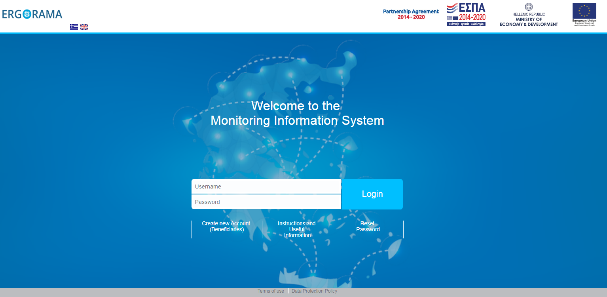
- The User chooses language and then presses “Project – Programmes”.
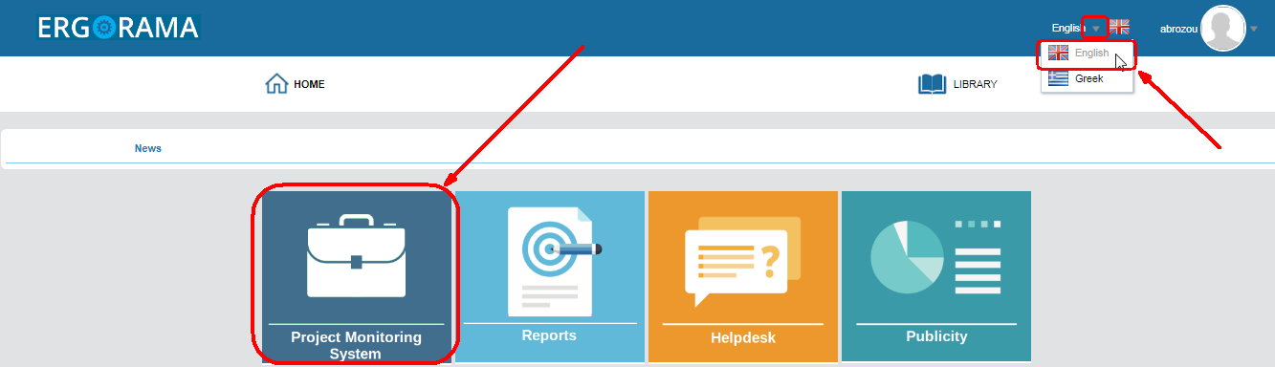

Monitoring System Main Screen
The screen on the MIS interface is divided into four (4) areas (red fields), as displayed on the figure below.
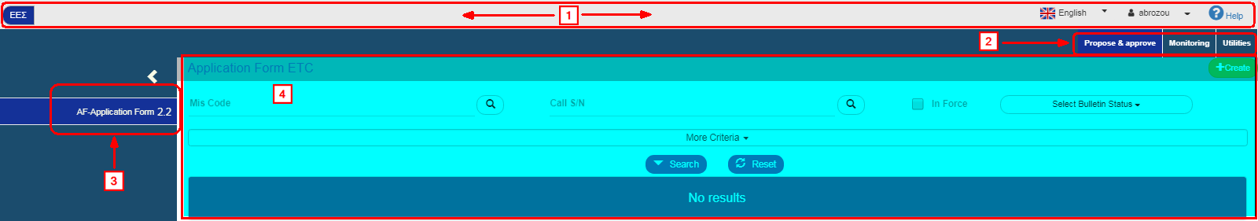
The first area contains the following:
- NSRF / ETC: NSRF (and funds such as the Fund for European Aid to the Most Deprived (FEAD/ΤΕΒΑ etc.) or ETC programs and projects
- Choose language: Greek or English
- Username of the User that logged on. By selecting the pop-up list the Logout option is shown.
- Instructions: Possibility to display instructions and notifications about the Project
The second Area is the menu showing the system's Operating Areas depending on the User’s roles and rights. Selecting an Operating Area from the menu determines the Options that will appear on the sub-menu of Area 3.
The third Area is the sub-menu displaying the Application Forms corresponding to the selected value of the menu depending on the User’s competences and rights. Using the symbols the User can display or hide the full descriptions of the Application Form:
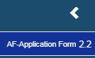
The fourth Area is the User’s “working area”. It should be stressed that the Application Form selected by the User on the sub-menu and the respective search criteria are displayed on this Area.

Application Form Search Screen
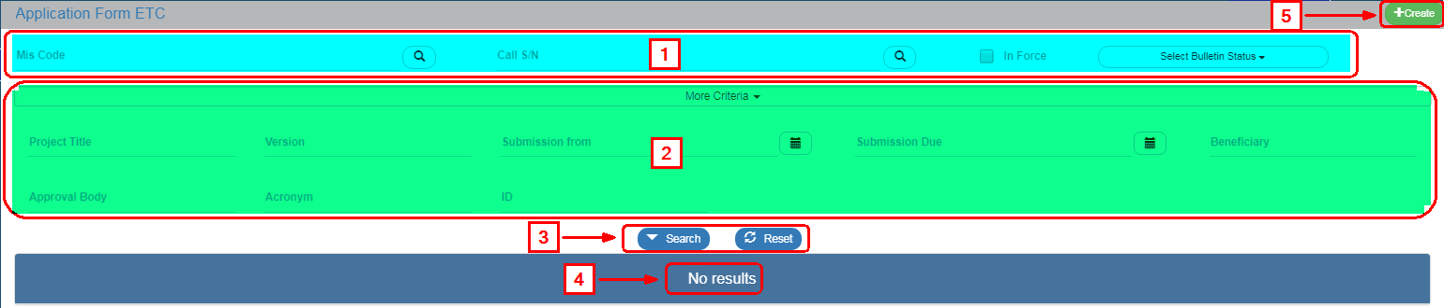
The search screen includes the following:
The main Search Criteria that are always visible
More Search Criteria through the display of the respective option
“Search” : it is selected to make a search
“Clear” : It is selected to clear the criteria and the results that are filled in from a previous search
Table of results (for more details see Par.2.3.3).
Select “Create”.
The system keeps the search criteria from a previous search (even the additional ones). The User is recommended to press “Clear” in order to empty any previous criteria, especially on “More Criteria” that are closed.
When the check box “In Force” is checked, only the In force Application Forms are shown on the Table of results, while when it is unchecked, all the Application Forms are shown.
The search results depend directly on the User’s rights and roles.

Fields with Search lens (Value List)
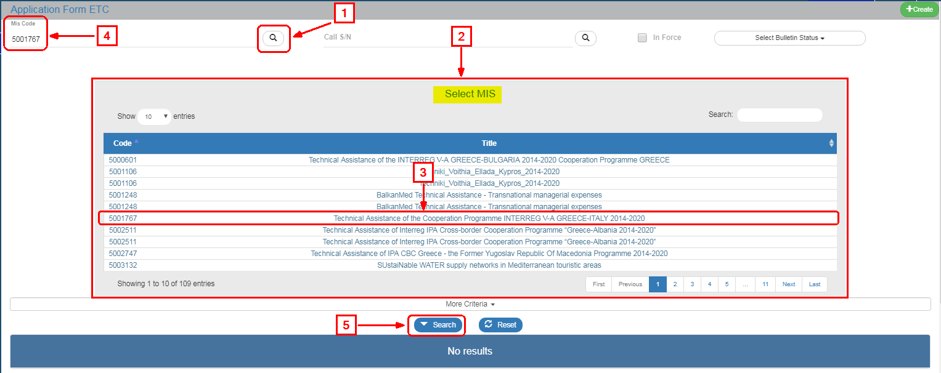
On the search criteria, the User may type the desired value or click on the search lens using the following steps:
Click on the lens e.g. in the “(MIS) Project Code” field
Display of the value list depending on the User’s rights
Select the appropriate MIS
The (MIS) Project Code is shown on the respective field of the search criteria while the value list is redacted.
Select “Search”
Moreover, the User can make a search among the search lens results (for a big number of results on the list of values).
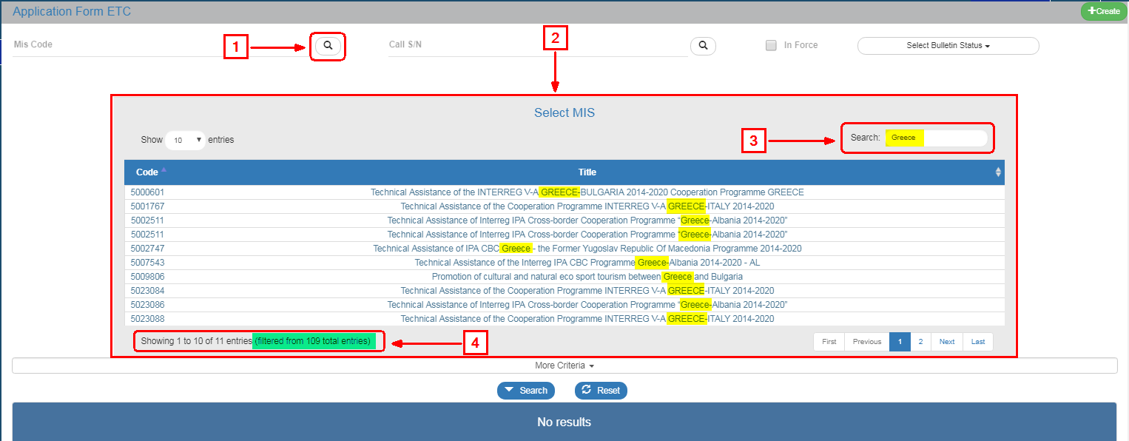
If the User types in the “Search” (3) field, he can filter further the results e.g. if he types the characters “SERV” there are less results(4).
Fields with search lensare displayed on the edit screens.

Fields with drop-down list
Fields with drop-down list, e.g. Select Application Form Status (Select Status)
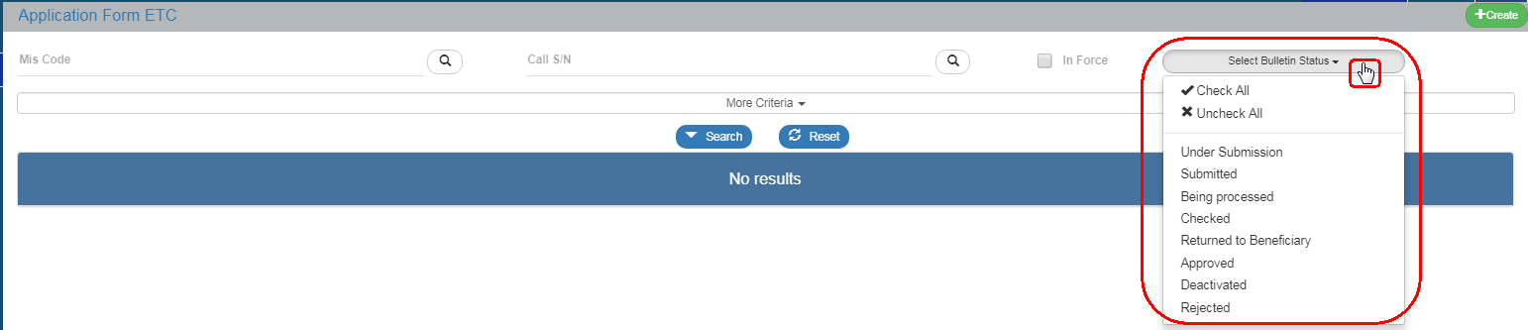
Pressing “Select Application Form Status” (Select Status) prompts all the values to appear and the User chooses one, many or all the list values.

Table of results
Based on the above, in order to perform a search successfully, the User enters the appropriate criteria (1) and selects Search (2) to see on the table of results the entries (3) fulfilling the search criteria.
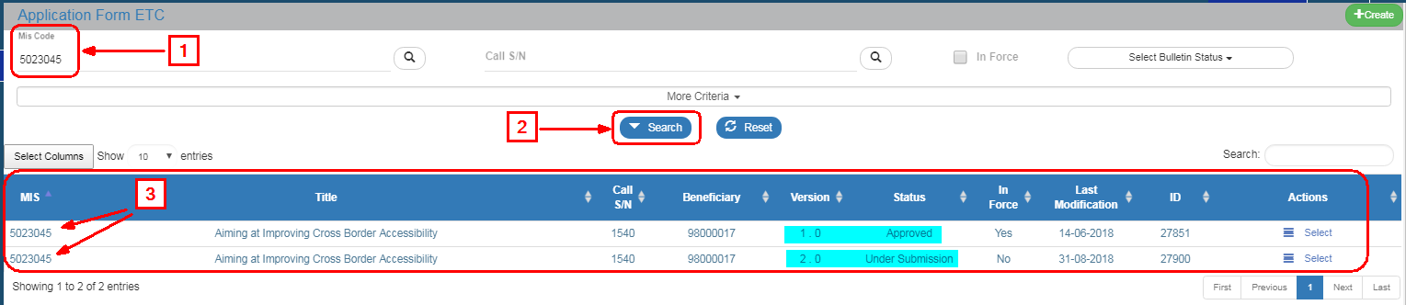
The Table of results offers a number of possibilities-information to the User.
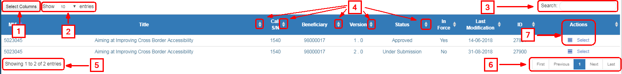
To display or hide columns select Search Results on the table of results.
Set the number of entries per page that will be displayed on the Search Results.
It is possible to make an internal search to all columns (that are displayed or hidden) of the table of results (see Section 2.3.1, same in operability with value list)
It is possible to classify the results in descending or ascending order clicking.
It is possible to align most columns using the “Shift” key on the keyboard and in the order the User selects the columns. The columns with a unique number such as the Application Form ID are excluded.
Display of entry directory of the table of results based on the selected criteria.
Navigation on the pages of the Table of results
Actions: Display of a pop-up menu with the Actions (Enabled and Disabled) depending on the Application Form status and the User’s rights and roles e.g. Edit, Review, Submit, Finalize etc.
If the user selects “Search” without entering search criteria, the Table of results can display up to 500 results.

Generating Application Form
After the User selects from the menu the Operating Area and from the sub-menu the Application Form that he wishes to work on, the interface is displayed and by pressing “Create” he can enter a new Application Form on the system.
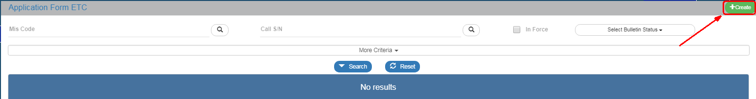
In most Application Forms, after pressing “Create”, a pop-up window appears for further options such as:
- Create: Create a new Application Form
- Modying New Version: Create Modification, Update, Corrigendum etc. of an existing Application Forms
- Copy: Create a new Application Forms by copying an existing one
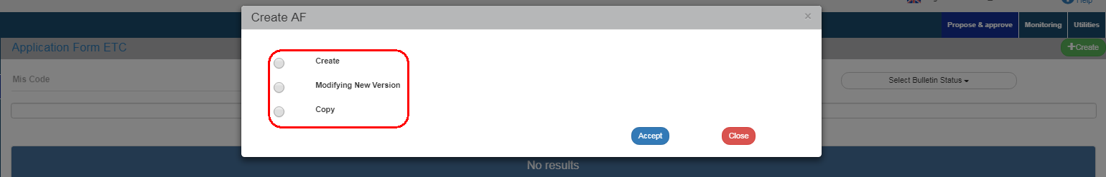
Depending on the Application Forms and the selected Action, the User may be requested to enter more parameters.

Create a new Application Form
To generate a new Application Forms, the User follows the steps described in par. 2.4 and after pressing “Create” (1), he fills in the mandatory fields (2) and then clicks on “Accept” (3).
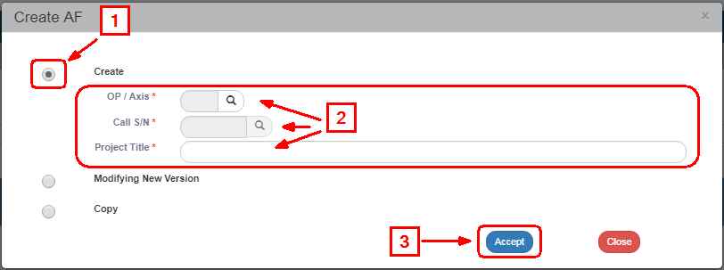
Fields marked with an asterisk are mandatory.

The system displays the entry screen entitled “Application form ETC - Create” (1).
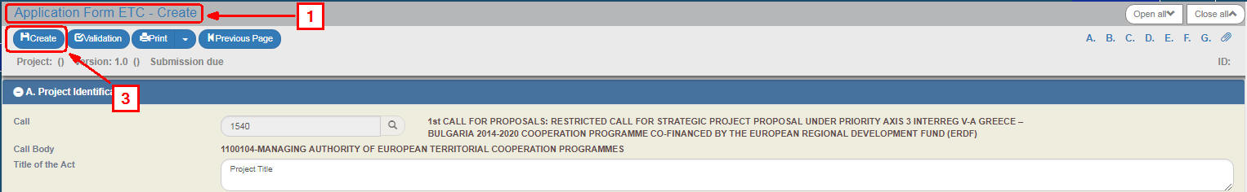
The “Version Category” field under the section “A. Project Identification” is granted an Initial value (2) and the system grants a Version to the Application Form. The User must then enter data on the mandatory fields and press “Create” (3) to generate-save the new Application Form.

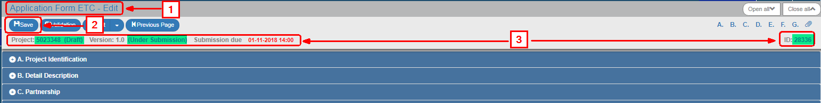
The title of the screen changes to “Application form ETC-Edit” (1) and the action “Create” is replaced by “Save” (2). Also, the system grants an “MIS Unique Code”, Project Status “Under Submission”, AF Status “Under Submission” (when the user is a Beneficiary) or “Being processed” (when the User is a Management Body) and a Unique system code (id). Also, the deadline “Submission Date Up To” appears from the Call.

Create a New Version:
To create a new version of an Application Form, the User follows the steps described in par. 2.4 and after selecting “Modifying New Version” (1), he fills in the mandatory fields (2) e.g. (MIS) Project Code and presses “Accept” (3).
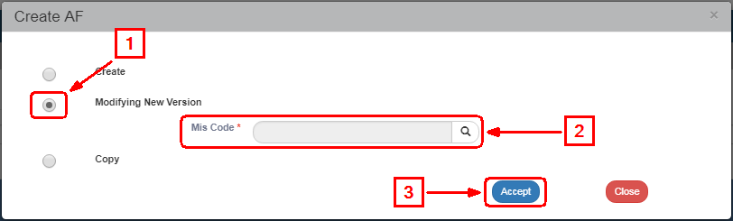
The system displays the “Application form ETC - Modifying New Version” (1) screen, as shown on the figure below.
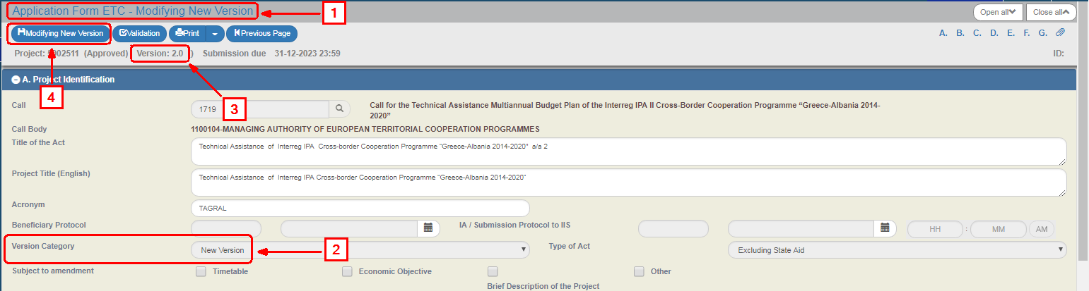
The “Version Category” field under “A. Project Identity” section is granted a New Version (2) and the system increases the Version Number of the Application Form (3) by one unit (e.g. from 1.0 to 2.0). The User selects “Modifying New Version” (4) to save the new Application Form.

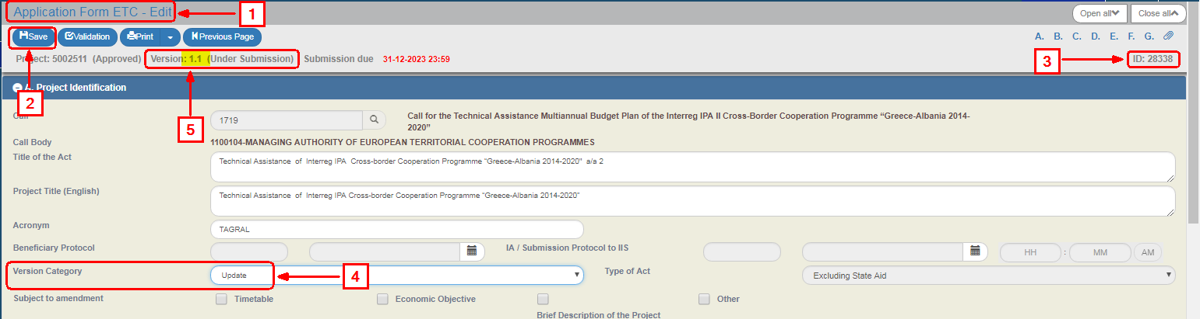
The title of the screen changes to “Application form ETC-Edit” (1) and the action “Modifying New Version” is replaced by “Save” (2) and a new ID is granted to the new Application form (3). Also, the User is given the possibility to edit the “Version Category” field (4) and select CORRIGENDUM or UPDATE. In such case, the system changes the version 2.0 to 1.1. (5) automatically.

Creating through Copy
To create a new Application form through copy, the User follows the steps described in par. 2.4 and after selecting “Copy” (1), he fills in the mandatory field “(MIS) Project Code” (2) and presses “Accept” (3).
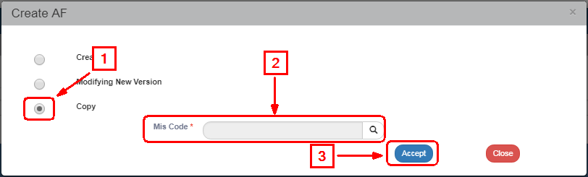
The system displays the “Application form ETC - Copy” screen, as shown on the figure below (1).
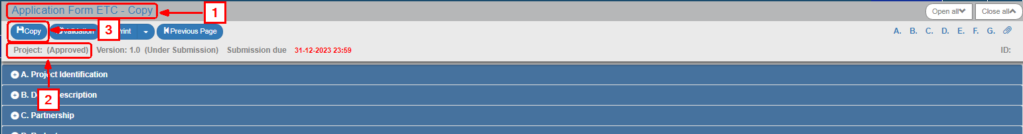
The Project Code is initially empty (2). The User changes the appropriate fields (e.g. Project Title etc.) and clicks on “Copy” (3).
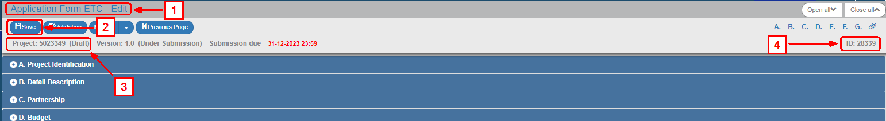
The title of the screen changes to “Application form ETC-Edit” (1) and the action “Copy” is replaced by “Save” (2). The system grants automatically an MIS Code, a Project Status (3) and a Application form ID (4).

Detailed Screen of the Application form
The detailed screen of every Application form includes the following areas (the AF is presented indicatively).
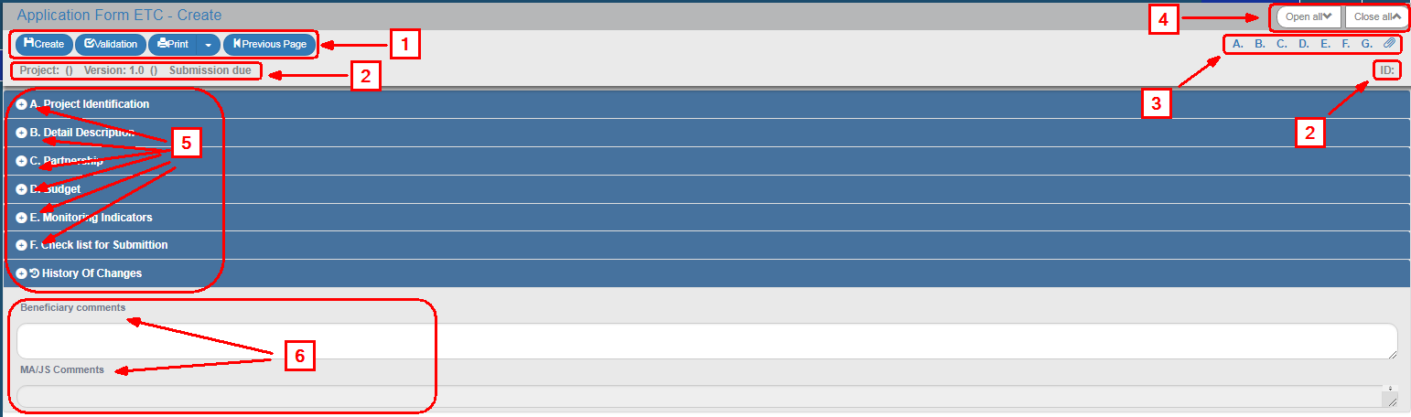
Action bar of the interface as described below.
Application form Data: MIS, Version, Application form Status, ID, etc.
Options for display and transition or minimize (hiding) a specific section of the screen
Options for display or minimize all screen sections (e.g. A, B, C.D etc.)
Display/minimize a specific section of the screen e.g. A, B, C etc.
Fields for entering comments about the Beneficiary and the Management Body
A detailed presentation of the system’s Operating Areas and the Application form is provided in the individual manuals.
OPTIONS | INTERPRETATION
 | Save data
 | Check data reliability
Print a Application form in pdf or rtf format. In some cases, the “Document Data” option is displayed to fill in the data transferred to the Generated Documents.
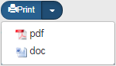
 | Return to the initial search screen

Grids
Most of the data entry screens include Grids. The process of entering, editing and deleting data on a Grid is described in the following sections.

Entering data on a grid
- Assuming that the User is in “A. Project Identification” section of the AF and wants to enter the “Classification”. He moves to the respective grid and selects “Add”.
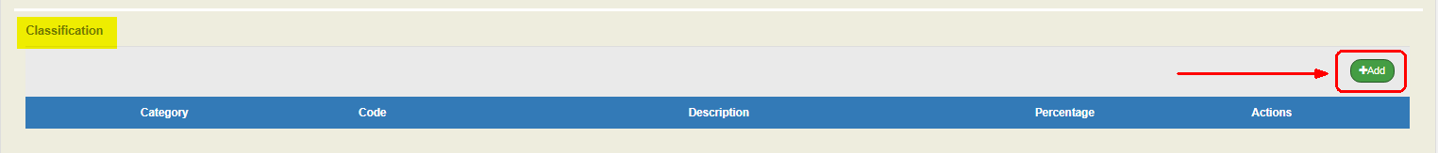
- The following pop-up window appears where the User selects the “Code” using the search lens (1), types the percentage (2) and presses “Accept” (3)
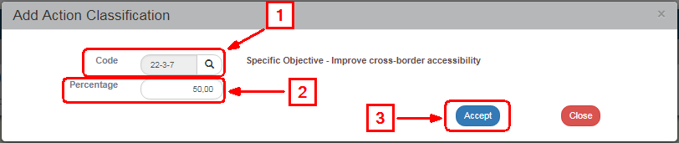
- The system introduces the data on the grid and “cleans” the window fields to proceed to the next entry.
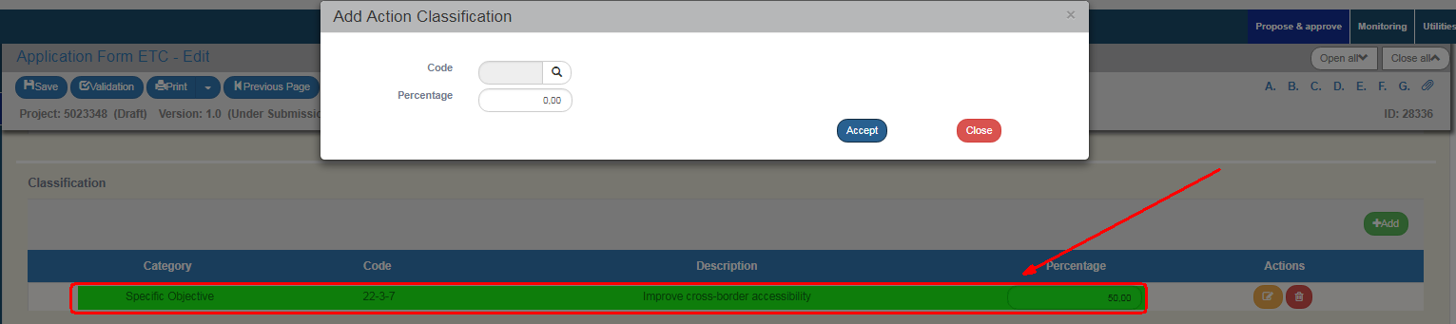
- The User makes the next entry repeating the steps 2 and 3.
- When the User finishes introducing the Classification entries, he selects “Close” on the pop-up window and returns to the main screen.
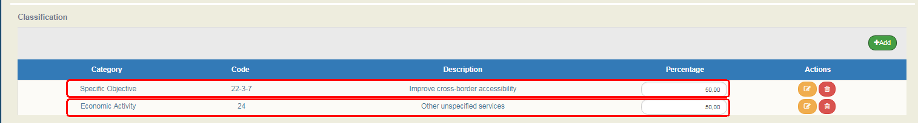

Editing data on a grid
- To edit an existing entry on a grid, the User selects Edit in the respective entry:
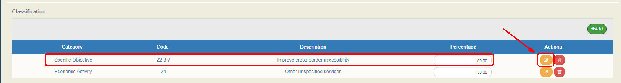
- The pop-up window with the data of the selected entry appears. After making the necessary corrections, the User presses “Accept” (2):
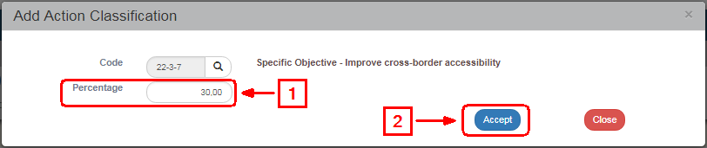
- The system displays the change in the specific entry.
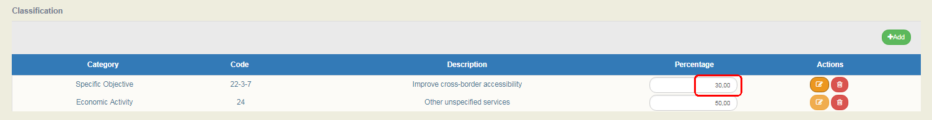
On the MIS, there are grids where the User can edit data directly on the table. On the above example, such fields are the percentage field and, usually the fields that are filled with numbers. On the contrary, the “Code” can only be edited through the pop-up window (select ).

Deleting data on a grid
To delete an existing entry on a grid, the User selects Deletein the respective entry:
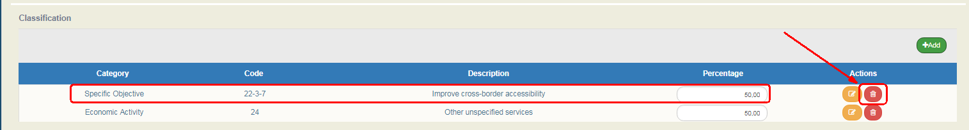
- A pop-up message with a warning message appears. He selects “YES” to complete the deletion process.
- If he does not wish to delete the entry, he selects “NO”.

Other options on the grid
Apart from the above options, the MIS also offers the following options:
OPTIONS | INTERPRETATION
 | Indicator analysis. Additional information is provided about the indicator
 | Deployment of a table row to display dependent data (e.g. Work packages/Deliverables in the ETC sub-system)
 | Minimizing a table row to hide dependent data (e.g. Work packages/Deliverables in the ETC sub-system)

Attaching Documents (Attachments)
- To attach a new file, the User selects "Attach a new file” in the relevant section of the Application form.
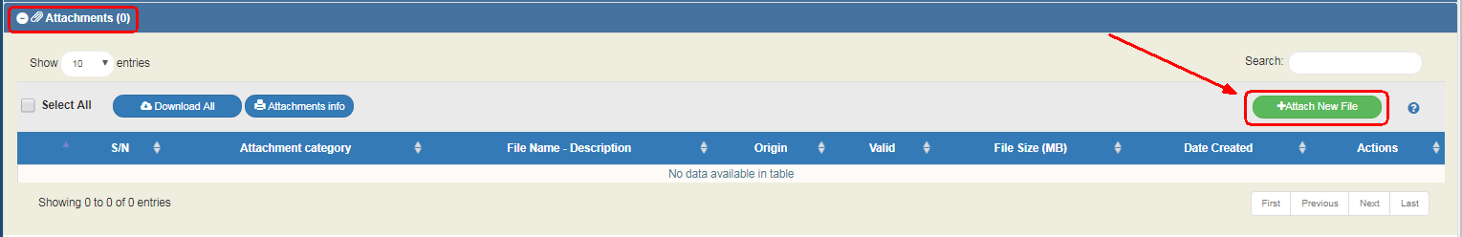
- A pop-up window appears and in Section "Step 1: Select the file on your computer that you want to attach", the User presses "Choose file" »
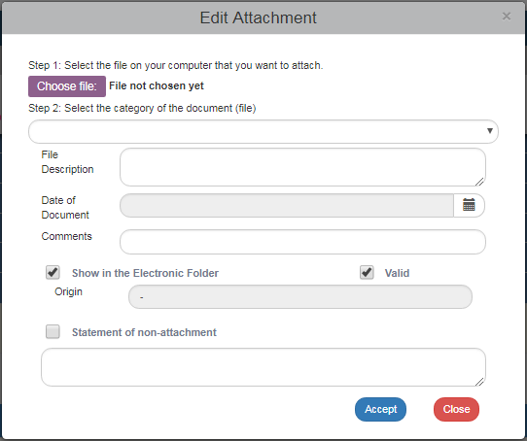
- In the pop-up window of the User’s operational system, the User searches and attaches the File he wants to attach.
- The User moves to Step 2 “Select the category of the document (file)” and after selecting the appropriate category from the pop-up list (1), he fills in the remaining fields (2) and finally presses “Accept” (3).
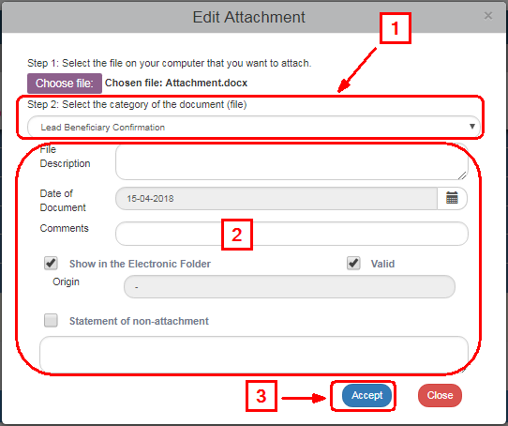
The "Shoe in the Electronic Folder" and "Valid" check boxes are for the MA use only. The "Non-attachment Statement" check box must be accompanied by a justification of the grounds for non-attaching a compulsory file.
- The system returns to the main menu, where the file (1) has been added to the table of attachments. Also, next to the title "Attachments" there is a number indicating the number of screen attachments(2). The key constitutes a link to the "NSRF 2014-2020 Announcements" (3).
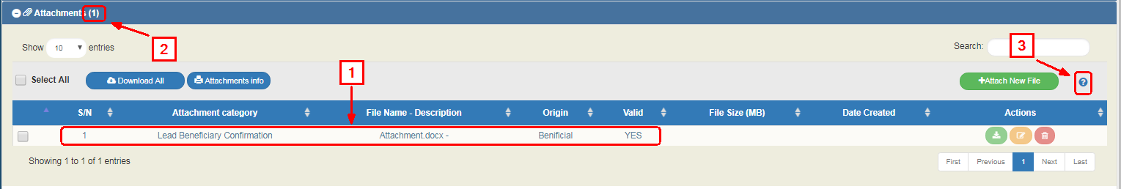

Downloading attachments
- To download an attachment from the Table of Attachments, the User selects "Download file"
- The browser displays a message for opening or saving the file in the computer and the User can choose the file name and the location on his computer to store it.
- To download more files, the User chooses the files that he wishes to download using the check boxes on the first column (1). To download all the files, he can choose the "Select All" (2). Then, using the function "Download All" (3), he saves all the selected files in his computer. Through the "Attachments Details" function, the User can print a summary of the table entries (4).
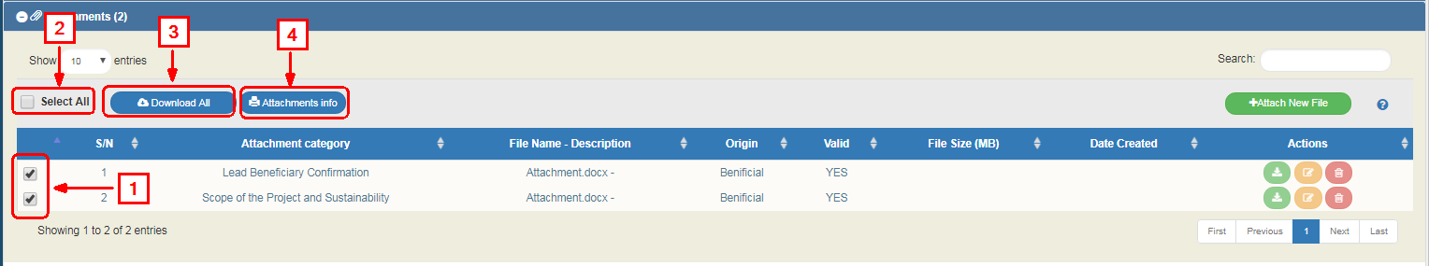

Editing & Deleting attachments
To edit an attachment, the User selects the Edit function on the grid, while to delete an attachment, he selects the Delete function (see Section 2.5.1, same functionality on tables).

Change history
The last section of each Application form is the “Change history” displaying all the Table of Expenditure’s status changes as well as:
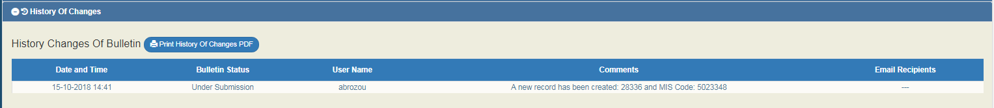
- System Date and Time
- Application form status
- User's name
- Action Comments
- E-mail recipients
By selecting “Print Change History of the Application form” the User can print the Change History in pdf.
In particular, in the case of the e.g. “AF- Financing Application” there are two tables. The first one includes the change history of the Application form, while the second one the change history of the Project’s status, as shown on the figure below:
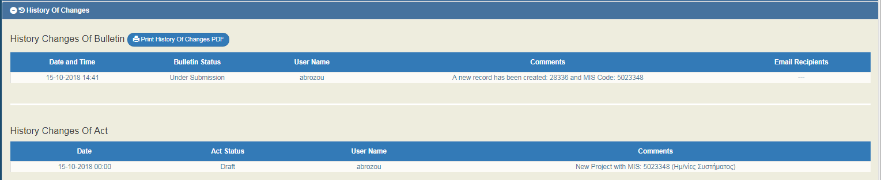

Application Form- related Actions
On the search menu of a Application form, as specified in Section 2.3 and in the Table of results, there is a column entitled "Actions".
By pressing on the selected row, a pop-up list appears with Enabled or Disabled Actions depending on the Application form status and the User’s rights and roles.
On the AF (Application form ETC) screen, if the User is a Beneficiary, the following options appear:
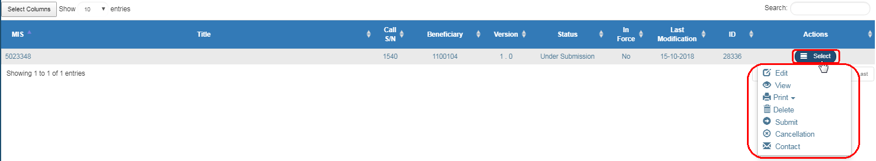
If the User is the MA/IB, the following options appear:
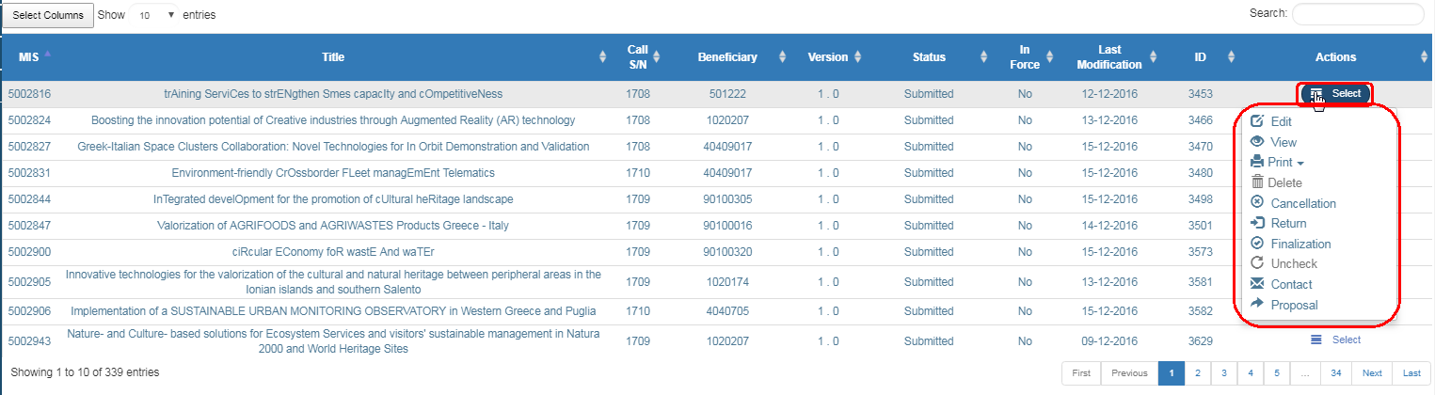

Application Form submission by a beneficiary
If the Beneficiary wishes to submit a Application form, he selects “Submit”from the pop-up list,
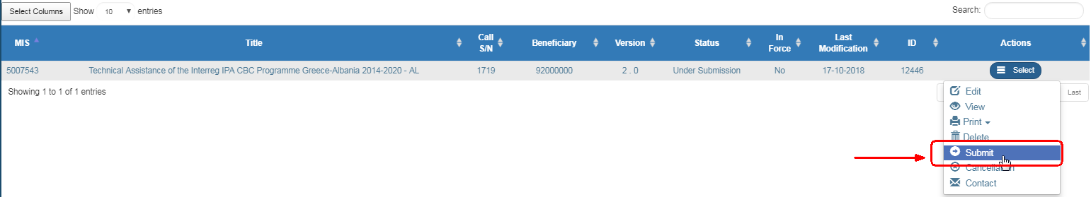
the system transfers him to the “Application form ETC - Submit” screen with the option “Submit” , as shown on the following figure:
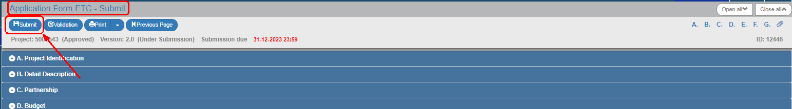
- By clicking on "Submit", the system carries out logical validation controls and displays:
  - Either an error message (requires a correction) and a warning (it is to the User’s discretion to make or not corrections) detected on the Application form.
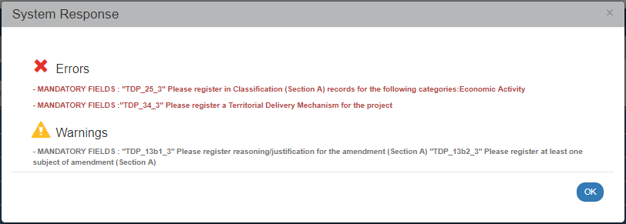
  - Or an "Action Confirmation", where the user, after entering comments, he clicks on "OK" to complete the submission of the Application form.
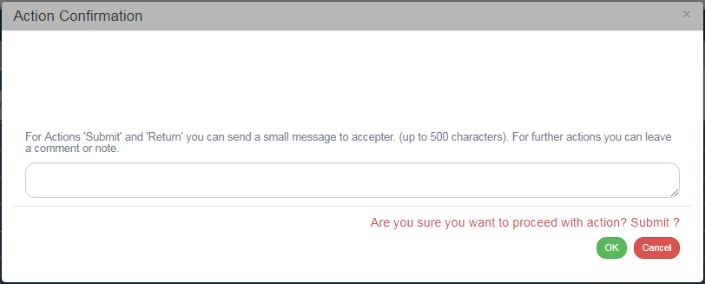
The system grants:
- The status “Submitted” to the Application form.
- The screen changes from “Application form ETC - Submit” to “Application form ETC - View” and the key “Submit” is replaced by the “Save” key (which is disabled in Preview) (1). The Beneficiary does no longer have the possibility to edit the AF because he submitted it to the MA/IB.
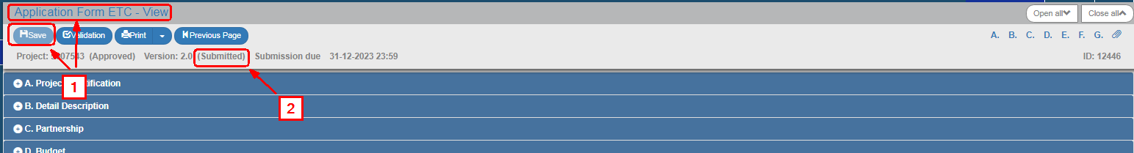

The following table presents all the Actions (either for the Beneficiary or the MA/JS).
ACTION | INTERPRETATION
The Edit form action allows the User to recover a form in order to enter and edit data.
After completing the Create actions (New form New Version or Copy) the title on the screen changes to Edit.
The View Form action allows the User to recover and view a form without the possibility of entering and/or editing its data.
After performing the Submit, Reject, Cancel, Return, Finalize and Uncheck actions, the status of the form changes from Create to Review.
 | The Print action allows the User to print a form in pdf or rtf format.
 | The Delete action allows the User to delete permanently a form from the system. After clicking on Delete, the User is taken to the search screen. Deleting a form is only possible when it is in ‘Under Submission’ status and fulfils some requirements e.g. it has not yet been submitted, returned etc.
 | The ‘Cancel’ action does not delete a form from the system but changes its status to Invalid/Disabled and allows the User to recover it with View. The action is not valid for the Table of Expenditure.
 | The Finalization – Check of the form (only for the Managing Authority/JS) allows the User to perform the final check and ‘lock’ the form, in order to inform the Certified Authority that it is ready to be included in a payment claim.
The ‘Uncheck form’ action (only for the Managing Authority/Intermediate Body) allows the User to undo finalization (uncheck) in a Finalized form which returns to a ‘Being processed’ status. Unchecking a form is only possible it does not have any dependent elements.
Also ‘Uncheck’ is possible for forms under status‘ Returned to the Beneficiary’ . The form status changes to ‘Being processed’ (for the Controller).
 | The Submit action (only for the Beneficiary) allows the User to submit a from to the Managing Authority/Intermediate Body.
 | The Table of Expenditure Return action (only for Controllers), takes the Table of Expenditure to the Beneficiary for corrections.
 | It consists of a two-way communication between the MA/JS or the Controller and the Beneficiary, in the form of texts and attachments sent to make a request or ask for additional information.
 | This action (only for Controllers) consists of verifying and forwarding the Table of Expenditure to the relevant bodies.
This action consists of submitting a form in a “Being processed” status from the MA/JS that processed it to the MA/JS competent body that will Finalize it.
This action generates an automatic notification (email) and automatic saving of the form’s recorded data in pdf format.

